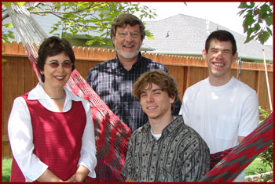

David & Crissie Rask
Mission Aviation Fellowship (MAF)

Dave and Crissie Rask and their children, Ian and Evan, are missionaries with Mission Aviation Fellowship. For 16 years, they ministered in four different MAF locations in Papua, Indonesia, helping to support Bible translators, national church development and medical work.

Then, in 1999, when Dave was appointed manager of Safety for MAF, they returned to serve at the MAF home office. Today, as director of Aviation Resources, the Lord is using Dave’s overseas aviation experience, wisdom, and managerial skills to coordinate the work and deployment of all MAF aircraft and related equipment worldwide.

With the merge into MAF-International, Dave also has a significant role in working on standardizing flight operations models.

