Brad & Kritian Westom
MAF

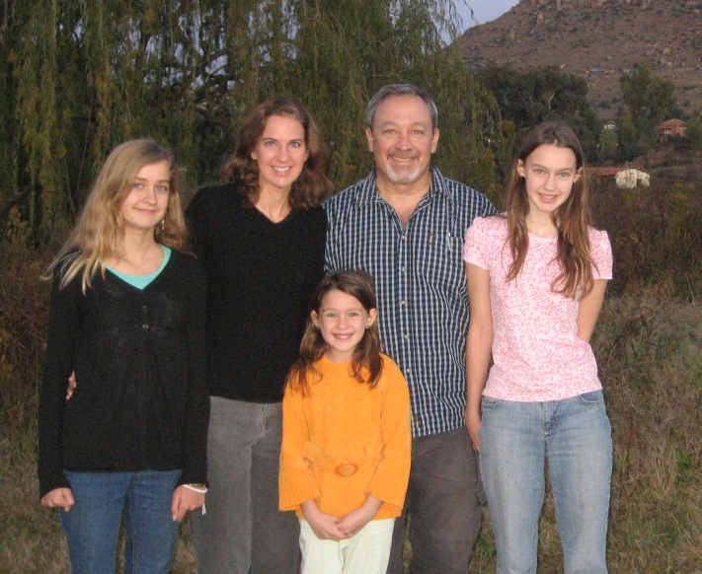
Brad and Kristian Westom joined MAF 1993. They have 3 daughters; Karisa- 14, Elisa 12, Brianna 9.

They have served in Lesotho (in southern Africa) for 8 years. The are currently on furlough visiting family and friends in the US.

Brad says “It is a privilege to meet so many physical needs, flying sick and injured people from the mountains to Maseru and the hospital, and then back out to the mountains when they are well. It is also exciting that MAF hired a Masotho Chaplin that can witness to the patients and show the love of Christ to them as we fly them out of the mountains. Another highlight is that we were able to help build a church building in the mountains, partnering with churches from the US.”
Brad is the Program Manager of Lesotho. He has also been active on the Elder, Deacon Council at their local church. The last 3 years he has been the chair of that council.

Brad’s guiding verse: Rom 8:28 NIV God is in control, no matter what. I might not understand, but I trust Jesus, and need to listen to hear how He wants me to respond.

