David & Karin Reese have been wonderfully married for 21 years. Karin hails from Indiana, while David grew up in Tennessee & Alabama. They met while at Bob Jones University, where Karin graduated in 1988 with a B.S. degree in Biology, and David graduated in 1989 with a B.S. degree in Physics/Engineering Sciences.
David & Karin were married in May of 1989 just before David joined the US Air Force in the fall of 1989. David served in a variety of procurement, logistics, and leadership roles while both Karin & he developed a deep love for taking care of others as they traveled the globe in military service. In their various churches over the years, they both gravitated toward service roles where they were able to minister others, whether in music ministries or simply supporting other workers from a behind-the-scenes role.
Karin has served in a variety of roles in support of Sunday School, children’s church, AWANA, church office, and praise & worship teams over the years. She has also directly assisted the deaf ministries at two churches, including the transcription of weekly sermons for inclusions on their former church’s website for the past eight years. Karin was also a vital part of David’s Air Force duties over their 20 year career, especially during their two command roles where Karin was intimately involved in caring & feeding (literally!) of the people serving in David’s squadrons.

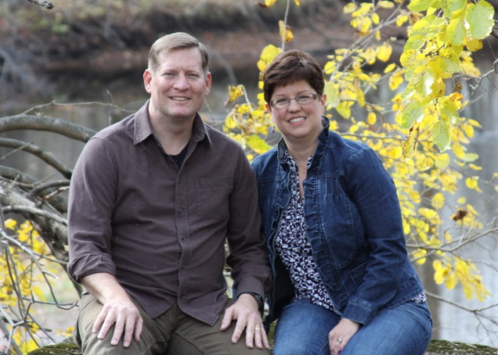
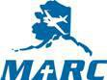

Biography of
David & Karin Reese
David & Karin
After retiring as a Lieutenant Colonel from the Air Force in 2009, David spent a year with LG Electronics in Englewood Cliffs, New Jersey serving as their North America Procurement Director, where he was responsible for $1 billion in contracts across the US, Canada, and Mexico. However, the satisfaction of working in the corporate world just wasn’t comparable to the satisfaction they had both felt while being a part of the military and helping serve others.
Seeing the need for providing the unconditional love of Christ to the people of Alaska and their many physical & spiritual needs, David & Karin joined the MARC team in September 2010 and are now enjoying the next chapter of their lives. David & Karin are both involved with development and communication outreach activities at MARC.
They are the proud humans of three extremely spoiled cats named Taspinar, Duchess, and Mo.

