Lee V. Smoll, Executive Director
Mission Aviation Support Association
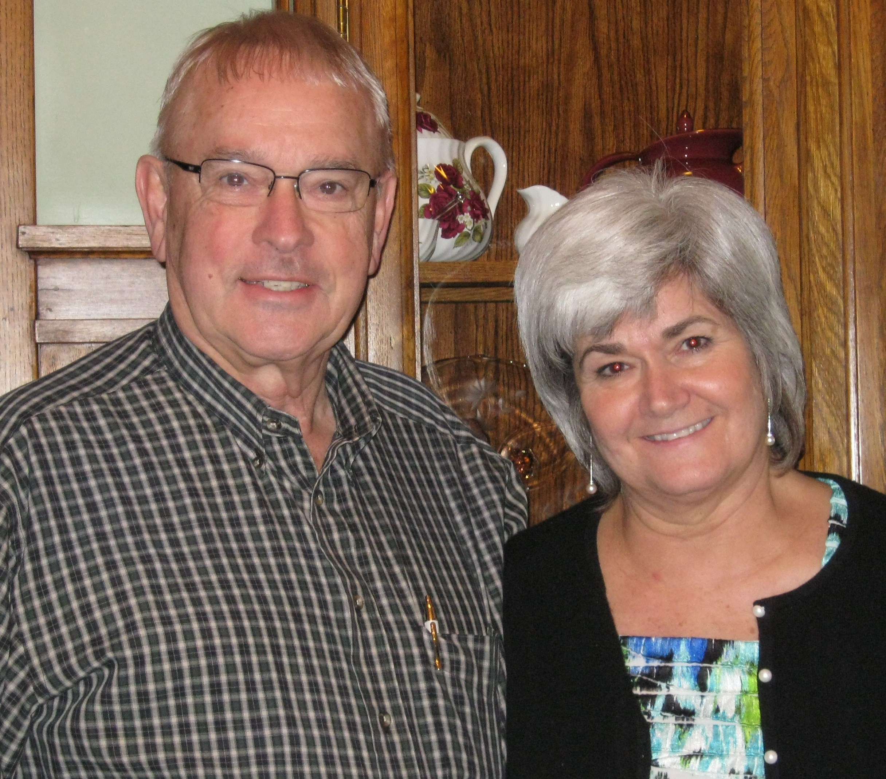

When Lee was in high school in 1956, the events in Equator impressed him with what God could do with an airplane and willing servants. That event and exposure to a mission aviator from his church greatly influenced his ambition. Lee got his BS in education, with a focus in Industrial Arts, at Bowling Green State University in Ohio. Following graduation, he served as a Lieutenant in the US Air Force and obtained his private pilot’s license. Following his military service, he applied to Moody Aviation but circumstances prevented his attending. With the help of the GI bill, he went on to get his commercial and instructor ratings. Lee taught junior high and high school for several years, worked in industry, and eventually started his own business. He is now enjoying retirement.

Lee has been tirelessly involved in church leadership from AWANA Commander, choir director, song leader, Sunday school teacher, missions committee member, small group leader and board member.

His passion for mission aviation, however, remained unchanged. God refocused his energy to providing hospitality to the missionary aviators at the Oshkosh AirVenture. The ministry began in the early 80’s when Lee and his children camped alongside the JAARS missionaries and began to see some needs that could be met by the local believers. At first one woman and her church provided meals and housing. But as other mission groups began attending the EAA AirVenture, Lee worked at getting more churches involved in the ministry. Eventually teams of volunteers were formed and the ministry developed into the 501(c)(3) ministry known as MASA (Mission Aviation Support Association). Lee is currently the Executive Director of MASA and is accountable to a Values Driven Governance Board of Directors.

