Gordon Bakke

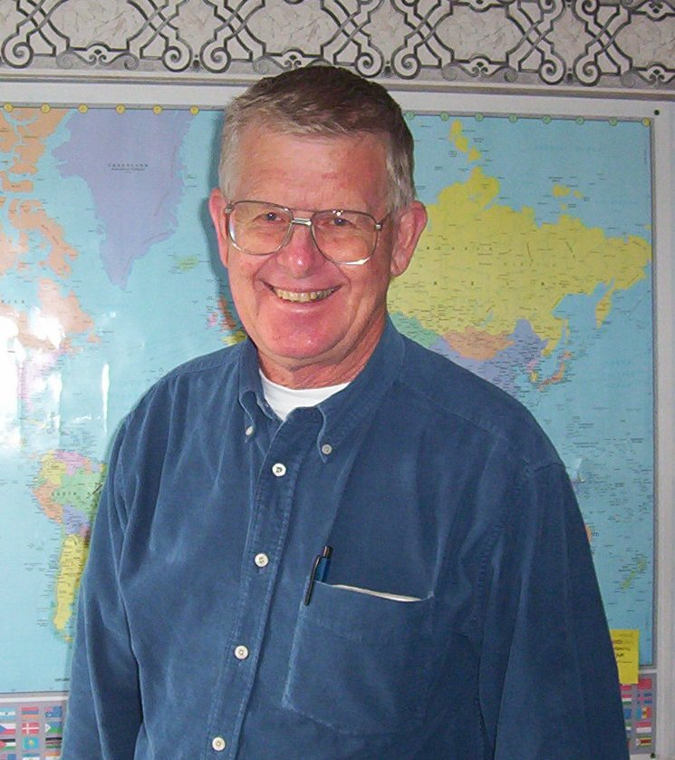

Mission Aviation Training Academy

Gordon Bakke was born in Bellingham, WA, attended Mount Baker schools, and graduated from High School in 1956. In July 1949, at the Firs Bible Camp, he received Christ as Savior and Lord and made the commitment to serve Him. He completed four years of Bible School at three schools (Moody, Kings Garden and Multnomah) graduating from Multnomah in May 1964. Married Elaine Dalseg in August 1962. Three weeks later moved to Portland. Elaine, who graduated from the UW with a BS in Nursing, took the one-year graduate course and Gordon took two years to finish up the three-year diploma course. In October 1964, they went to Tulsa, OK so Gordon could attend Spartan School of Aeronautics to recieve his Airplane Mechanics license (A&P license). During their second year in Portland, Gordon took flight training and received his Private Pilot's license. In June 1966, they returned to Mount Vernon. Gordon worked in Bellingham getting experience working on airplanes and, during that time, got his Commercial Pilot's license. In August 1967, they attended candidate school for Africa Evangelical Fellowship (now SIM) and, in December of that year, they left home for Zambia, Africa to serve as missionary pilot/mechanic and nurse for Mukinge Mission Hospital Nurses Training School. They moved back to the USA in April 1989. Since then, Gordon has made short-term trip to Africa in 1995, 1998 and 2002.
Gordon started with MATA (Mission Aviation Training Academy) about a year after Pastor Mike Crowell began the organization, which was October 1998.

Current Work Title: Executive Director, MATA.

Ministry Vision: One-sixth of the world lives where airplanes are the best or only practical way to reach people. So the need for missionary pilots is great!
For the past six summers, Gordon has flown his airplane to Western Alaska to help out with the Bible Camp flying for Kako Retreat Center.

