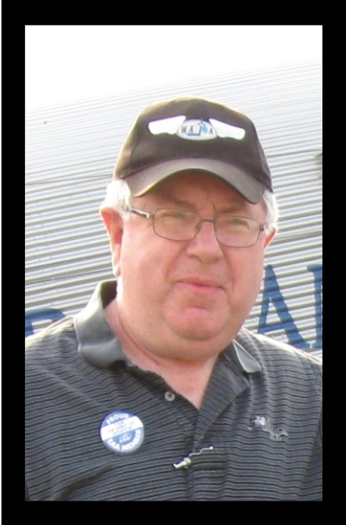
Myron K. Davis
Myron grew up in Coumbia, South Carolina and earned a Bachelor of Biblical Education degree from Columbia Bible College. He then attended Spartan School of Aeronautics in Tulsa, Oklahoma to attain an aircraft mechanic rating with the intention of going into mission aviation. However, with the Vietnam conflict underway, Myron served a tour in the U.S. Air Force. After his Air Force service Myron attended Western Conservative Baptist Seminary in Portland, Oregon. God again changed Myron’s direction and he went back to work on aircraft in the general aviation arena. Eventually, Myron moved to Everett, Washington, to work on corporate aircraft. Myron taught aviation maintenance at Everett Community College for four years, then resumed work mainitaining corporate jets. He currently maintains a Bombardier Challenger 300.
Myron has served on the Board of Directors of Mission Aviation Training Academy (MATA) as Recording Secretary since 2003. His goal as a Board member is to help MATA in the ministry of training men and women to serve Jesus Christ in mission aviation. He hopes to devote more time in this effort after retiring in the near future. Myron and his wife Martha have four adult children and five grandchildren.

