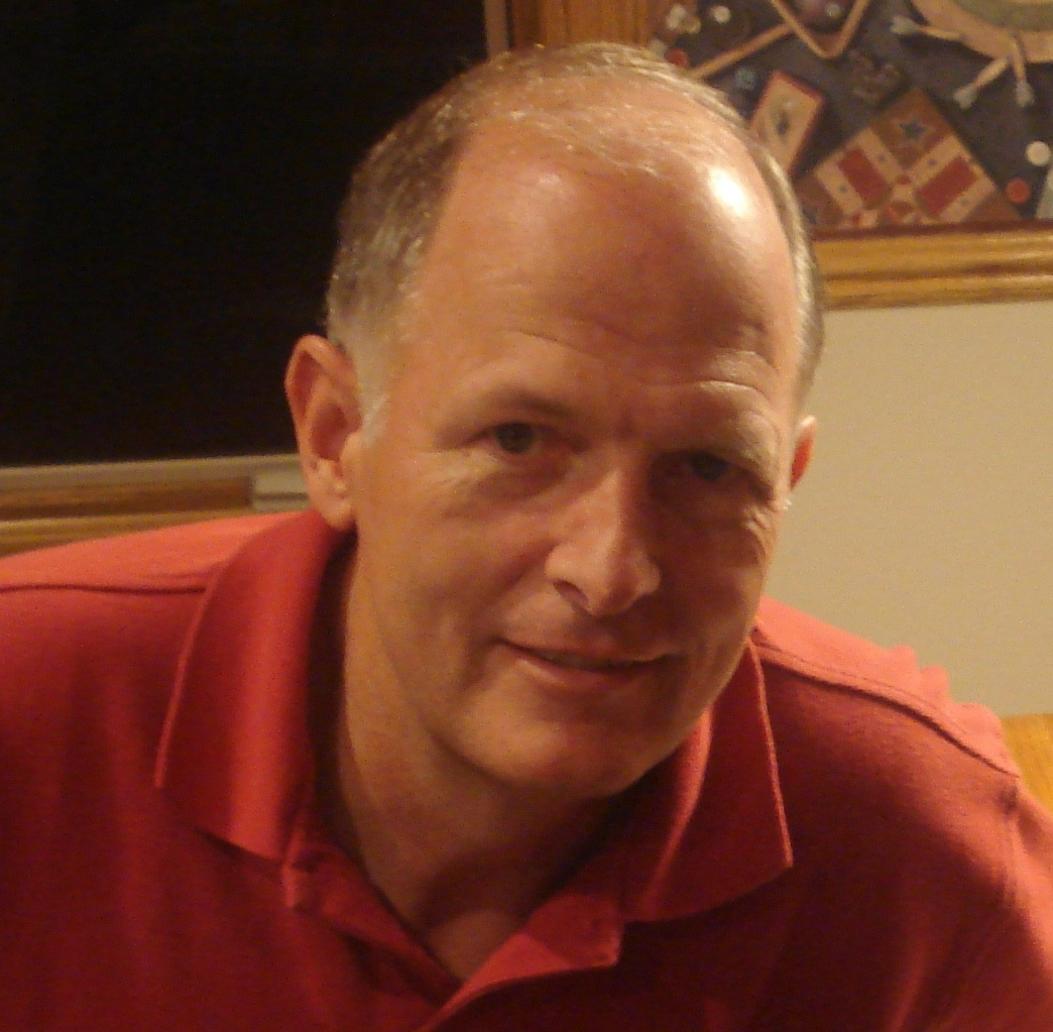

Gary Elliott

Mission Aviation

Training Academy

Gary Elliott graduated from the U.S. Air Force Academy and served 20 years, mostly as a fighter pilot. After retiring, he and his wife Stacie trained with New Tribes Mission (NTM) for 2 years then served 8 years in the Philippines. Gary serviced missionaries in remote jungle and mountain areas, operating a Cessna 180 and 185 from short, steep, narrow grass airstrips on the sides of mountains and in river valleys. Although not an A&P mechanic, he had lots of hands-on experience inspecting and maintaining the aircraft, working under the supervision of NTM Aviation's Chief Mechanic in the Philippines.
While on furlough in 2001-2002, he taught in Central Washington University's Flight Technology Program, providing classroom instruction in subjects varying from private pilot ground school and meteorology to advanced aircraft systems. Gary has over 3,600 hours total time, over 1,400 hours of instructor pilot time, and holds CFI and CFII ratings in single-engine and multi-engine airplanes.

