Calvin D. G. Willard
Missionary Aviation Training Academy

Cal Willard was born one of four children, in Salem Oregon in 1954 and baptized at Jason Lee Methodist Church in 1955. He graduated from Lincoln High School, Portland Oregon in 1972, and earned a Bachelor of Science degree from Oregon State University in 1976. Commissioned an Ensign in the U.S. Navy through the NROTC program, Cal Willard served as a Line Officer in the fleet for 24 years and retired from active duty with the rank of Captain in 2000. He commanded the Frigate USS Wadsworth (FFG 9) from 1996 to 1998.
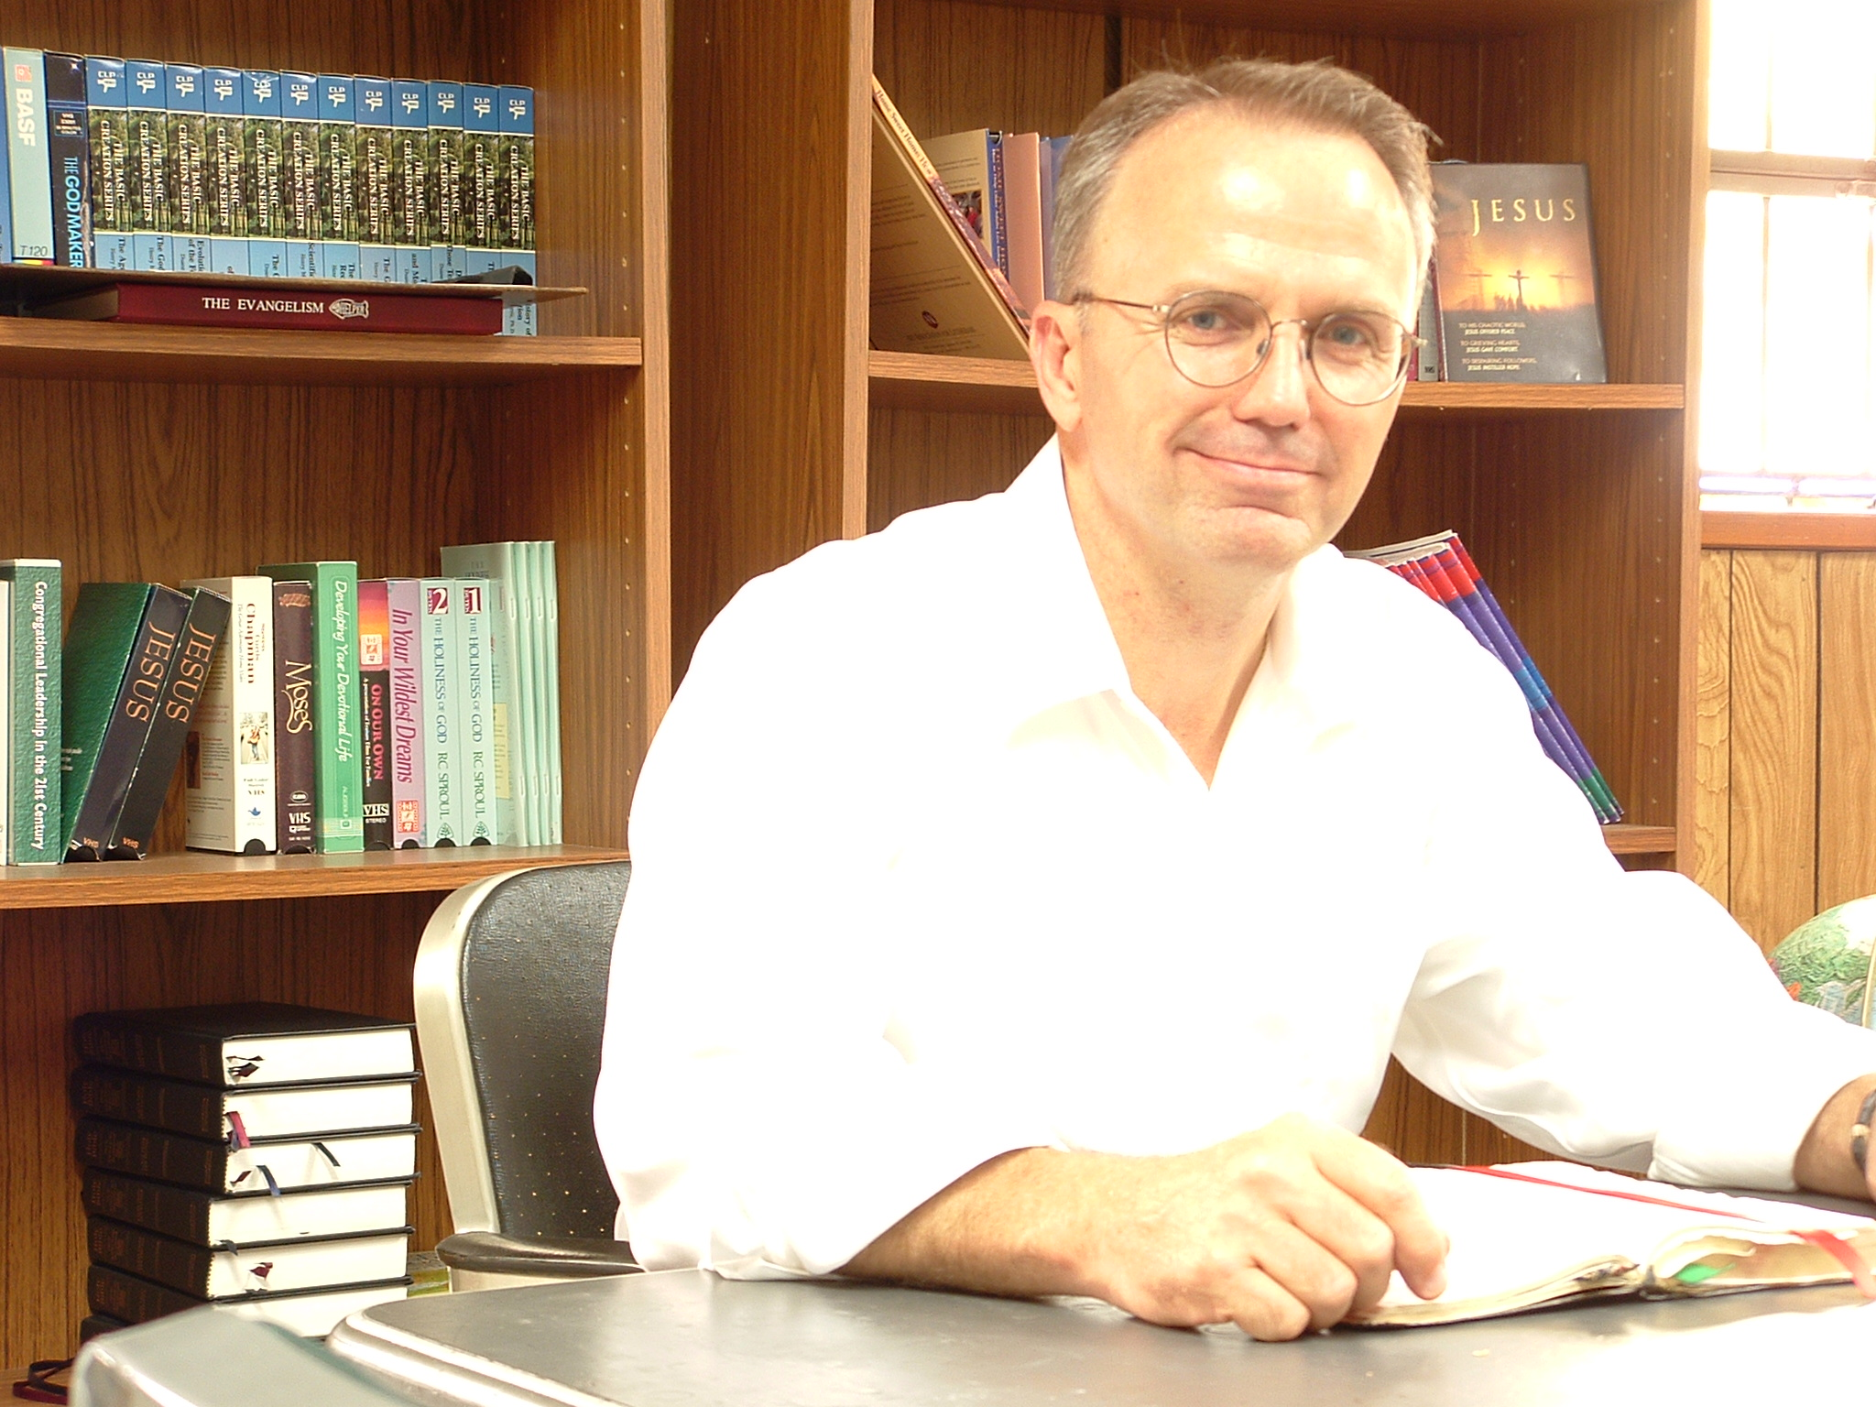

Cal Willard has earned his Master’s degrees in National Security Affairs from the Naval Postgraduate School, Monterey CA. (1982), in Business Management from Webster University, Saint Louis MO. (1999), and a Master of Divinity from AFLTS (2005).
Confirmed as a youth in the Methodist Church; Cal and his family worshiped in the Presbyterian Church for almost 30 years, always seeking orthodox Christian teaching and preaching. In 2000, Cal and his family came into the Free Lutheran Church, at Atonement Free Lutheran Church in Arlington Washington. Cal entered AFLTS in January of 2001, and graduated in May 2005. He completed his internship under Pastor David Barnhart at Peace Lutheran Church, Canal Winchester, Ohio.

Pastor Willard was called to serve at Messiah Lutheran Church, a start-up congregation at Champaign Illinois, in March 2005, and served there until February 2007. He is currently serving the Norland/Roseau parish, Roseau Minnesota.

Pastor Willard was widowed, and has two sons: Sam and Thomas, both students at Northwestern College, Minneapolis. Cal married Mrs. Lori Ann Crowell in December 2007.

