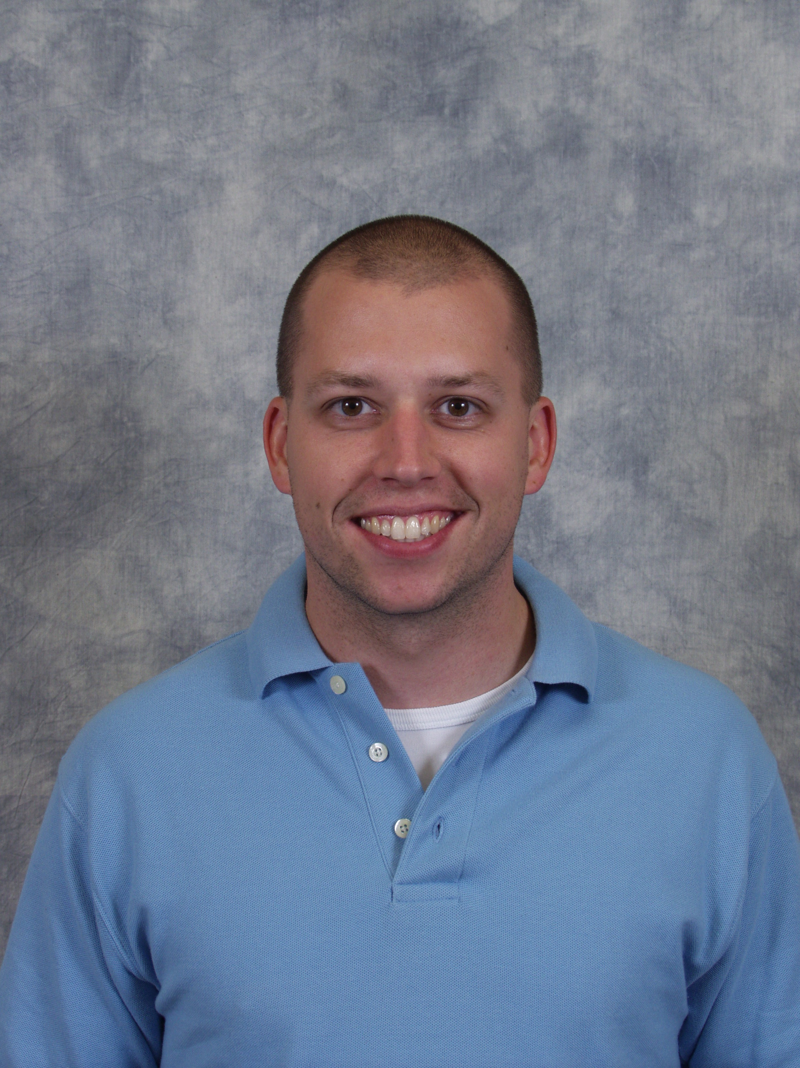
Rob Friebel
Midwestern Baptist Theological Seminary

Rob is a student at Midwestern Baptist Theological Seminary, in Kansas City, MO in pursuit of the Master of Divinity degree for his call to church planting in Greenville, WI. He holds a Bachelor of Science in Mechanical Engineering degree from Michigan Technological University and is currently serving as a Captain in the Air Force Reserves as a Civil Engineer.

Rob became a follower of Christ in 2000 while in college through Campus Crusade for Christ and received his call to ministry in 2002. In 2005 he married his wife Jen, after returning from a 6 month tour in Iraq.

