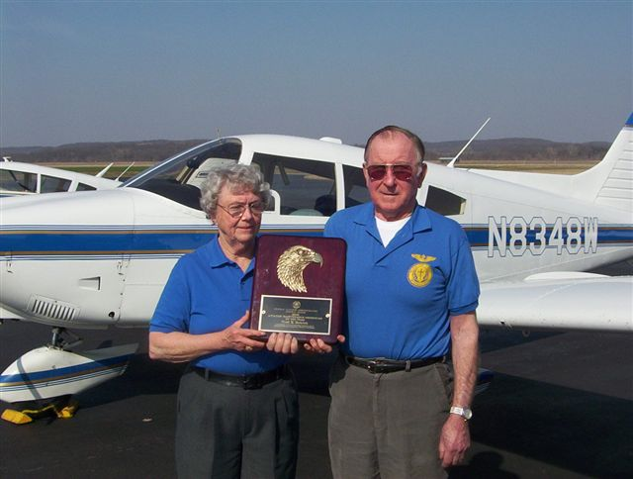

Fred and Doris Hetrick
Representing
Midwestern Baptist Theological Seminary

Fred started his own Aviation Maintenance business in 1967 in Topeka, Kansas. Fred retired so his 2 sons have taken over the business in Topeka and in Lawrence. He has also been an airplane and helicopter pilot for over 50 years.

Doris worked with Fred in the maintenance business. She is a pilot and mother of 3, (our daughter is in Colorado) with 6 grandchildren and 2 great-grandchildren.

Fred & Doris are involved with the Air Explorer Squadron # 8 and have volunteered with them at Oshkosh for 7 years. They are also active in their church, Pilots for Christ Inc. and Kansas Pilots Association. The Hetricks live on a private airstrip just outside of Topeka.

