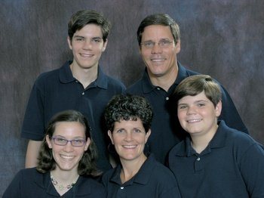

Joe and Wendy Karabensh
Missionary Flights International

Joe committed his life to Christ at a Christian family camp at Mt. Hermon, CA. when he was 13 years old. He later attended Westmont College and gained a burden for missions while on mission trips to Mexico and Kenya, Africa. His interest in missions, combined with his skill in mechanics, made him well suited for the role of "Missionary Pilot." He was accepted into Moody Bible Institute's Missionary Aviation Training Program. Before aviation school began, however, he set across America from California to find his wife.

Meanwhile, Wendy had grown up on Cape Cod, MA and had accepted Christ as her Savior at a young age. After attending Wheaton College and then earning her teacher certification at Castleton State College, Wendy was teaching school in Vermont. Joe's travels brought him to Vermont for the winter. He and Wendy met at church.

They were married in 1986 and together they went to Tennessee where Joe attended Moody Aviation and became certified by the FAA as a commercial pilot and an aircraft mechanic. After finishing at Moody, they moved with one child to Cape Cod. In Maine they had two more children, added a few gray hairs, a couple of pounds, and gobs of aviation experience (as a mechanic, flight instructor, and captain on a twin-engine plane with Cape Air/Nantucket Airlines). Then, in 1996, Joe began work as a pilot and mechanic with Missionary Flights International (MFI).

Based out of Florida's St. Lucie County Airport, MFI provides air support to 225 evangelical Bible-centered missions in Haiti and the Dominican Republic. MFI transports missionaries and mission cargo, provides mail service, and serves as emergency air ambulance using three Douglas DC-3's. The DC-3 is known as the airplane that changed the world by making passenger travel affordable. Today MFI is still using the DC-3 to change the world by helping missionaries spread the gospel in Haiti and the Dominican Republic.

Between flights, Joe works in the MFI office as the Executive Vice President and also keeps the MFI computer network up and running. Joe and Wendy live in Vero Beach, Florida and have three children: Gregory (1/88), Jenni (1/91), and Nathaniel (5/94).

