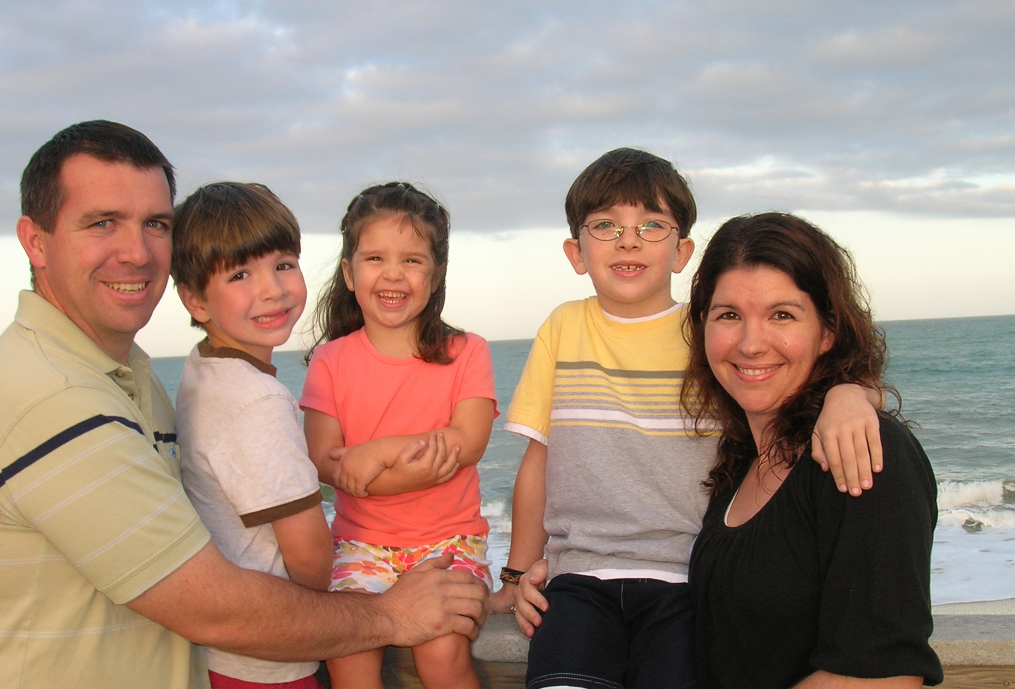

Brian & Terah Lites

Missionary Flights International

Brian & Terah Lites joined MFI in October, 2007. They are originally from Northern California where they had worked in Christian camping for several years. Brian received his aircraft maintenance training while serving as an apprentice with Missionary Maintenance Services Aviation in Coshocton, Ohio.

While working in Ohio Brian first learned of MFI when he had the opportunity to serve MFI on a short term trip to help with a major aircraft inspection. Brian and Terah were looking at opportunities to serve overseas when God made it clear that they were to be a part of the ministry of Missionary Flights. With MFI, Brian is serving as a Maintenance Specialist on the flight line. Brian & Terah have 3 children, Evan (8), Luke(6), and Sierra(4).

