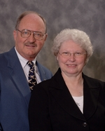
Richard (Dick) Snook
President & CEO
Missionary Flights International

Richard (Dick) Snook is the President and CEO of Missionary Flights International. Linda works in the office taking care of the accounting for the organization. Dick and Linda joined MFI in 1986 after leaving their home in Iowa and moving to South Florida. Dick succeeded Rev. Don H. Beldin as president in 1993. Dick and Linda have four grown children and eleven grandchildren. Dick served in the USAF and was trained in aircraft maintenance. During the Vietnam war, Dick served as a mechanic on the EC-47 aircraft. The EC-47 is the military version of the DC-3. After Vietnam, Dick earned all of his pilot ratings. Little did he realize that 20 years later, he would be a captain on the same type of aircraft he maintained in Vietnam. The Lord always has a plan for our lives.

