JON FOOTE
Missionaire International

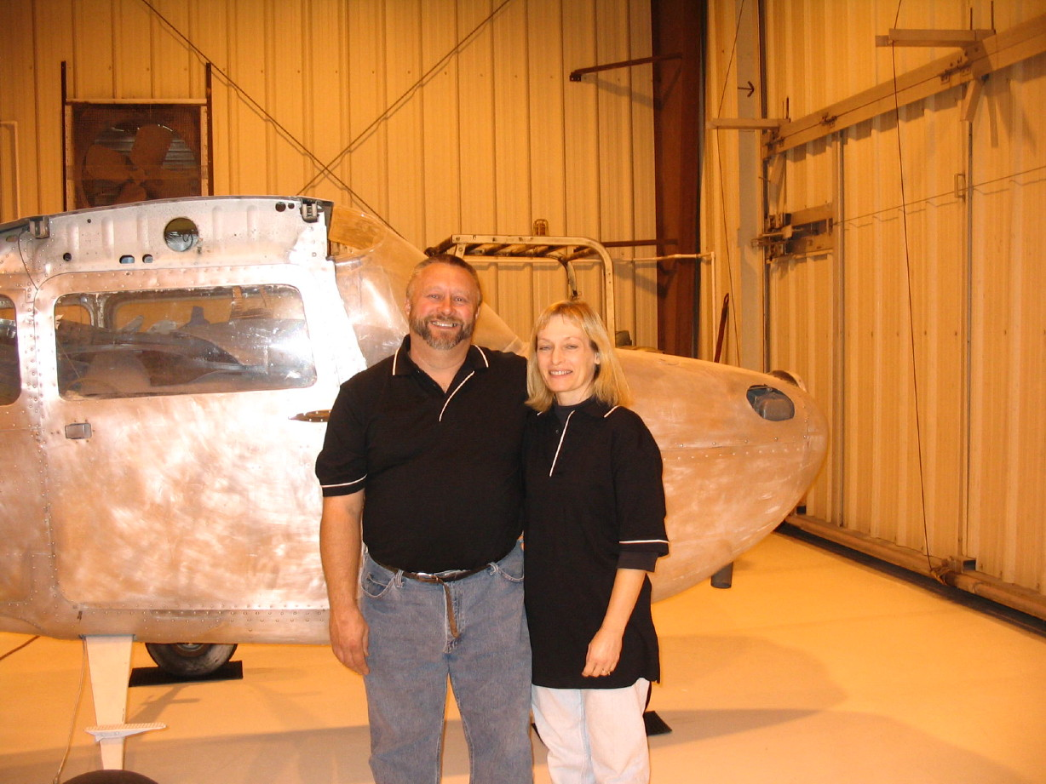
Jon grew up in a Christian home and accepted Christ at a young age. In high school he wrote a book report entitled, “How to Shrink a Head,” (based on the book Mission to the Head Hunters) as a way to witness to his teacher. Through this book Jon was introduced to missionary aviation.

Jon married his high school sweetheart (who was in school to be a nurse), completed aviation training, and they looked forward to being the “perfect missionary couple.”

In 1987, the Lord impressed on Jon and Lori that they were to “stay” rather than “go,” using their talents to help others get to the mission field. In 1987 Jon and his wife began Missionaire International in their single car garage. In the 20 + years since that time, God has been faithful to use the Footes to prepare a number of aircraft and people for service on the mission field all over the world.

Jon is an A & P, IA, pilot, and serves as Director of Operations for Missionaire International. Lori works as an LPN and also serves as Office Manager for the ministry. The Footes have 2 grown sons and 1 grandson. They currently care for Lori’s 90 year old mother in their home.

