Bruce and
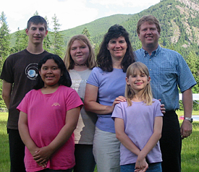
Bruce & Wendy DeVries
MAF – Moody Aviation
[Type a quote from the document or the summary of an interesting point. You can position the text box anywhere in the document. Use the Text Box Tools tab to change the formatting of the pull quote text box.]

Bruce and Wendy DeVries are missionaries with Mission Aviation Fellowship. After 10 years of service in Venezuela as a pilot/mechanic, the DeVries relocated in 2007, to Spokane, WA. Bruce is flight instructing, on loan to Moody Aviation. The DeVries are the parents of four children: Daniel, Rebecca, Emmalee, and Ana.

More information available at: http://www.maf.org/devries

