Biography- -Michael and Keila Dawson

Michael and Keila Dawson are missionaries to the Yanomamö Indians in the Amazonas region of Venezuela. Michael was born in the middle of the Amazon Jungle in a small missionary base called TamaTama, on the Orinoco river. He is the 5th of 10 children born to Joe and Millie Dawson who were among the first missionaries to the Yanomamo tribe. His first language was Yanomamö and he learned English when he was 7 years old. After graduating high school he worked for two years on the upper Orinoco river system taking portions of the New Testament to remote villages. The Yanomamo language contains many dialects and his purpose was to determine in what regions the current translation was understandable dialectally. He returned to the US for Bible School training in 1976 and finished missionary training in 79. He married Renée Pintor in 1980 and they left for Venezuela in January of 1981. They worked discipling new Yanomamö believers, traveling with them to different villages showing them how to evangelize their own people. They have three boys, Joshua, Ryan and Stephen.

In June of 1992 Renée went to be with the Lord after an attack of cerebral malaria. Michael was also stricken at the same time. They were both evacuated to the capital city of Caracas, but Renée did not recover. She is buried in the village of Coshilowäteli. On her headstone are the words “She lives in our hearts as a penetrating reminder that not only is Christ worth living for, He is worth dying for”. While she lay in a coma in the village for almost 24 hours waiting for an airplane to come in, the dream of having a plane based right up in the jungle to handle medical emergencies was born.

Mike and his boys continued working with the Yanomamö. In Oct of 1994 he married Keila Cornieles and they had two daughters. Mikeila and Mia. On January 12, 2006 Mikeila went to be with the Lord. Again the need of having an airplane based in the jungle was brought home in a real way to Michael because once again, no communication could be established with the mission providing our flight service. She died before anyone in town even knew she was sick. She also is buried in the village of coshilowäteli. Her stone reads; Jehovah es mi Pastor, nada me faltará, A Bible verse she loved, Our ray of light, Our spark of joy, Dwells now with the Shepard above.

Along with the need for an airplane in the jungle to handle emergencies, one is also needed for just traveling. Travel is difficult and, many times dangerous in the jungle. While distances are not that great, it can take days to get from one village to the next. Michael and Keila built an experimental CH 801 for use in their outreach program with the Yanomamö. The airplane was put in service in January of 2002 and has been a tremendous blessing to the outreach ministry, allowing contact with remote villages that would never have been reached any other way. This experimental airplane demonstrated the critical value of flight in the outreach program but has been down for a new engine for awhile now. The engine has been purchased and is now out in the nearest city waiting for a permit to be granted to either bring the fuselage out to the city or take the engine up to the jungle where it can be ressembled. The gov is extremely hostil to missionaries right now and they have indicated no hurry in granting the permits needed.

On the 12th of February 2006 all missionary flight programs were terminated in Amazonas Venezuela and the airplanes were taken out of the country. Currently we are the only evangelical missionaries still working in Indian areas in Venezuela. Mission Padamo Aviation and Support has been formed to fill the void caused by the other mission agencies having to leave the country. We are asking God to give us wisdom in positioning ourselves to step into this gap when things start changing politically here.

Along with taking care of Michael and Mia, Keila is director of the Yanomamö school and teaches preschool Yanomamö children. She enjoys her work, but is constantly having to defend her position and her school from the department of education. There is a hard effort right now to shut down all Christian schools in the country and especially those with the indigenous people. Keila is currently training some Yanomamö teachers to take over her job as director which will leave her more time to spend with the children.

Michael is the author of “Growing up Yanomamö” a book detailing his experiences growing up with the fascinating Yanomamö. Along with Tom Khazoyan, Michael is executive producer of the feature length movie “the Enemy God” (www.theenemygod.com) a movie based on the true story of how the Gospel of Jesus Christ has impacted the life of a Yanomamö shaman and his village.
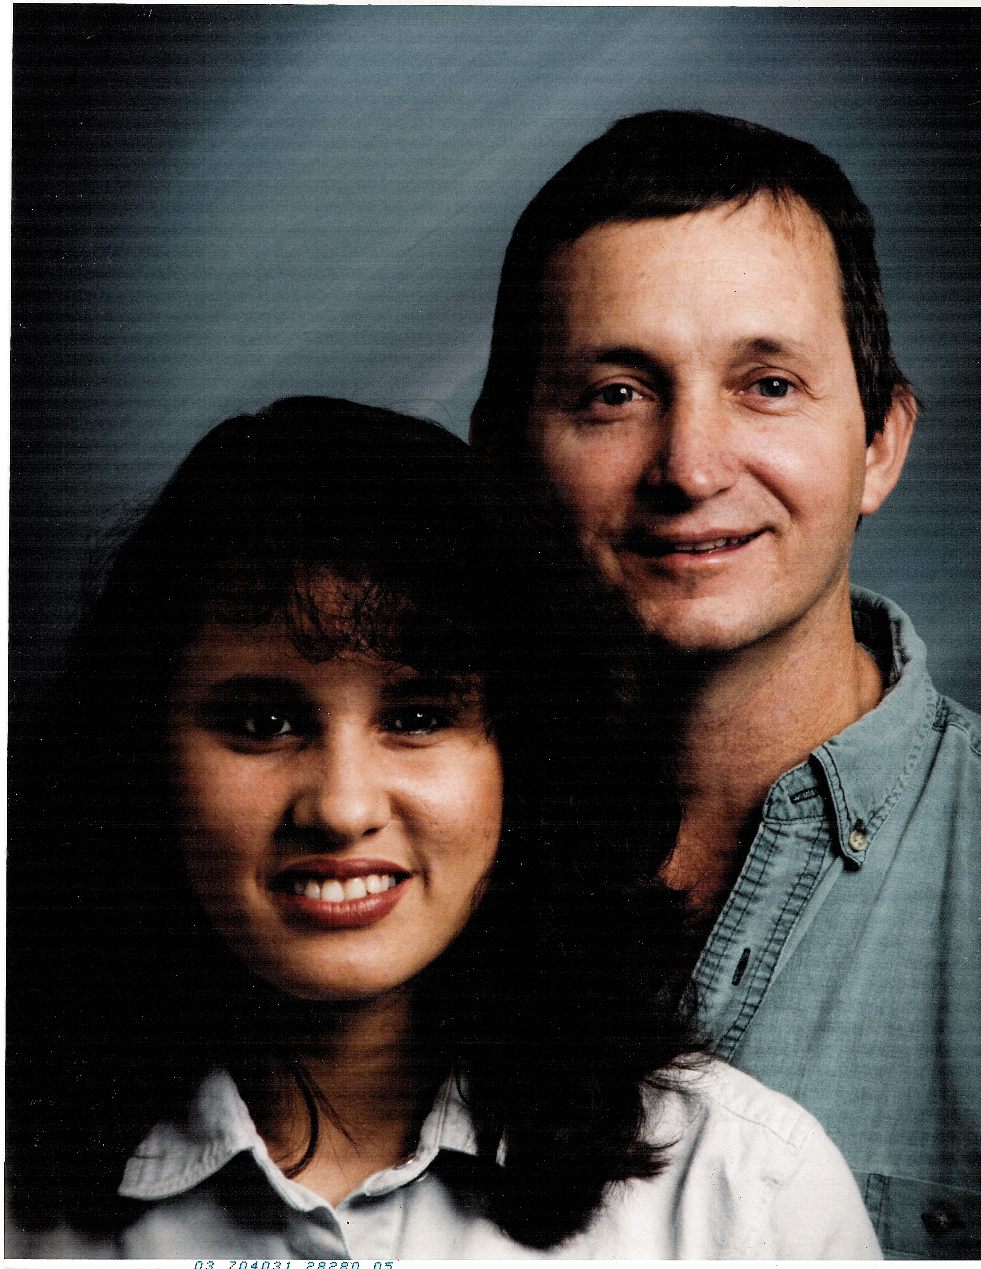
Michael and Keila Dawson

