Terry Brabon 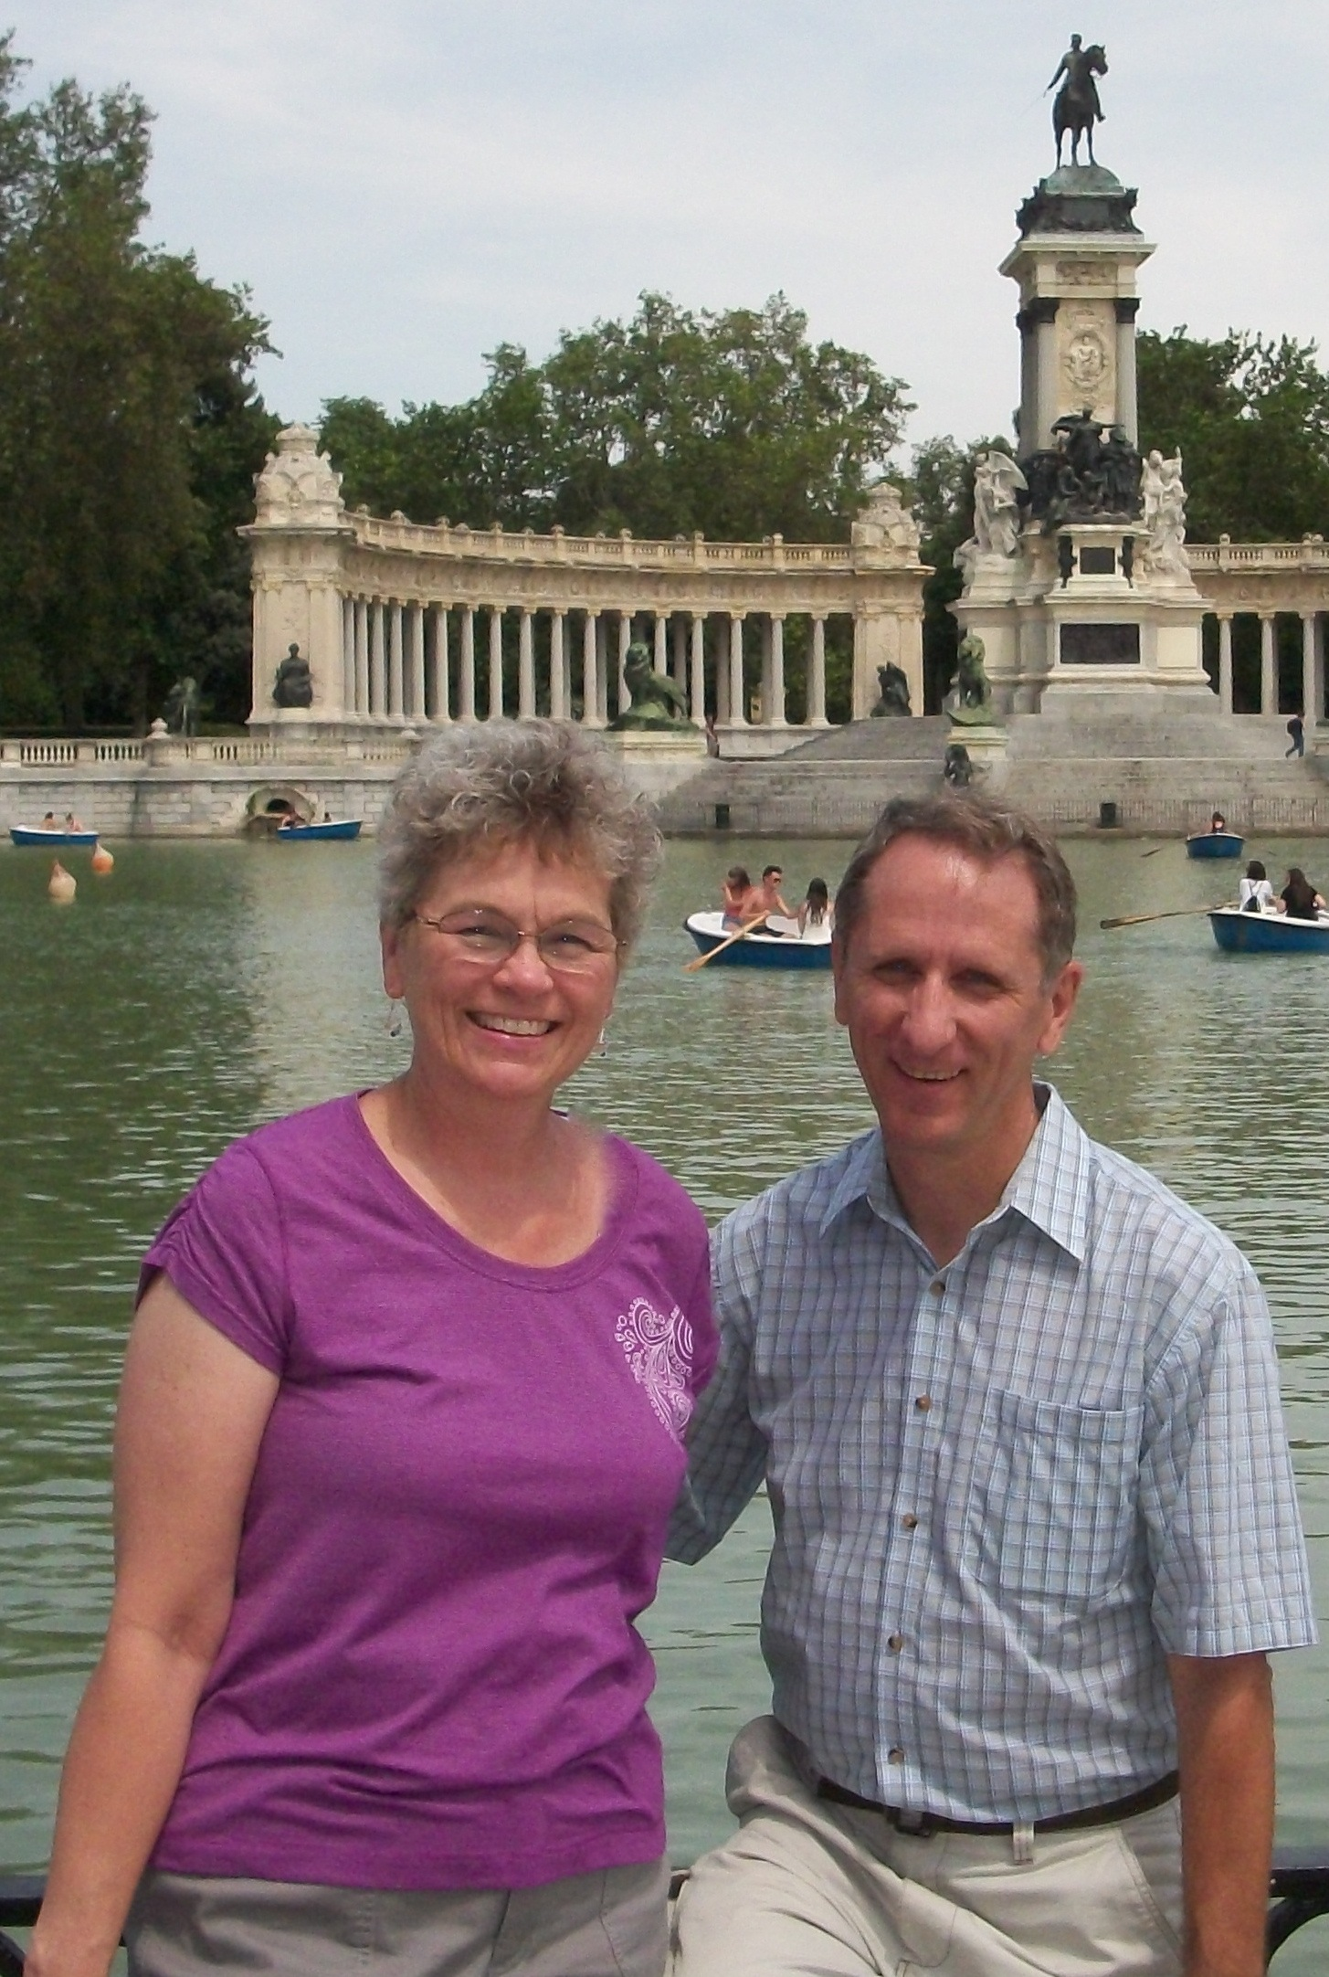

Born and raised in Michigan where he earned a BS in Trade Technical education from Ferris State University before attending Moody Aviation in Elizabethton, TN. His past work experiences include Aircraft Mechanic at a general aviation FBO in the Detroit area, before becoming a Flight and Aircraft Maintenance Instructor at GRSBM Aviation (now School of Missionary Aviation Technology). Later, he became Director of Flight Training at Northern Air School of Aeronautics in Grand Rapids, MI. which was then purchased by American Airlines. After obtaining his aircraft Flight Dispatcher license, he moved over to American in l988. He retired from American Airlines working the last 20 years as an Aircraft Flight Dispatcher.

Terry holds a Commercial pilot license with SEL, SES, MEL, and Helicopter ratings. His CFI ratings include Single Engine, Instrument Airplane, and Helicopter. He also holds an Airframe and Powerplant mechanics license with an Inspection Authorization.

Terry is currently serving as a volunteer with Mission Safety International. He and his wife Julie, have four grown children and two grandchildren.

