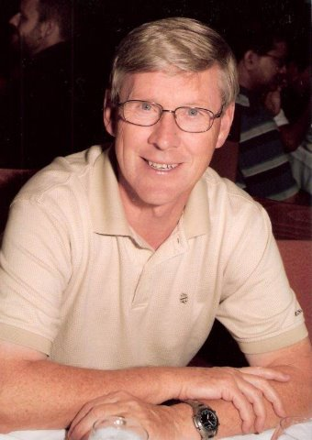
Steve Morrell
MSI
(Mission Safety International)
- Graduated from RAF Military academy in 1970 and flew for the RAF for 6 years before immigrating to Canada in 1974
- Flew in the “bush” and Canadian Arctic on DC 3, F27 and Twin Otter aircraft for two years
- Joined the airlines and flew Hercules in the high Arctic and worldwide before transitioning onto the B737, DC10, B767, and finally the A330/340
  - During time with the airline served in a training and/or Check pilot capacity as Second officer instructor on the DC10 and Hercules
  - Training Captain on the King Air and Instructor/ check pilot on B737.

- Completed various safety/accident courses and during a 3 year lay-off
  - Was an accident investigator for the Canadian Government.
    - As an ALPA and IFALPA accredited investigator assisted the airline as an accident investigator and critical incident de-briefer for over 20 years.

- Completed a Masters in Aviation Management in 2006 and has since taught a Safety Management Systems course as part of Master’s program for Newcastle University, Australia.

- Retired from the airline in December 2008.

- Currently works developing computer based aircraft ground school course
  - Serves on the Board of Prairie Bible Institute and, as a qualified auditor, conducts aviation safety audits.
  - For the last eight years has volunteered with mission organizations as an investigator/safety consultant and auditor.

Steve and Vanessa have been married for 40 years. They three daughters, five grandchildren and live in Vancouver BC.

