STEPHEN QUIGG
Mission Safety International (MSI) 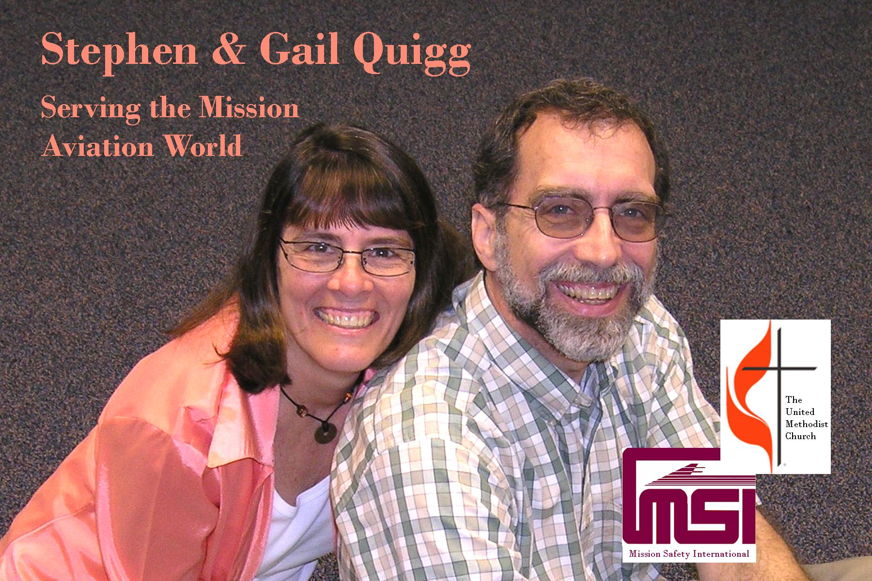
Serving as Vice-President for Field Services for Mission Safety International (MSI), Steve works to provide a variety of specialized safety services to mission aviation programs around the world. Safety surveys, security audits, safety seminars, continuing education events, and safety publications are all tools he is able to use to help insure that flying stays safe and secure.
Because of the remoteness and lack of technical support, much of the flying on the mission field today is conducted dangerously close to the “edge of the envelope”. His work helps bring the flying away from the edge and provides more success and a bit less tragedy in the lives of those who fly to serve the church of Jesus Christ.
Steve earned a degree in Aviation and Electrical Engineering Technologies from LeTourneau College, completed advanced flight and maintenance training at Moody Aviation, studied cross-cultural ministries at Asbury Theological Seminary, and completed a computer science minor equivalent from Asbury College. He is also a commercially rated pilot, a certified flight instructor, and an Airframe and Powerplant mechanic.
Steve and his wife Gail began their missionary career in 1979 in the small village of Bambur, Nigeria, where they worked with Air Muri - the aviation branch of the Nigerian United Methodist Church. The Quiggs’ next assignment was in the Democratic Republic of Congo (formerly Zaire) with the “Wings of Caring” flight ministry of the Central Congo Annual Conference where Steve served as a pilot and the Director of Maintenance. However, with the civil unrest in Congo shutting down the church aviation programs in 1999, the Quiggs returned to the States to work with their present assignment.

