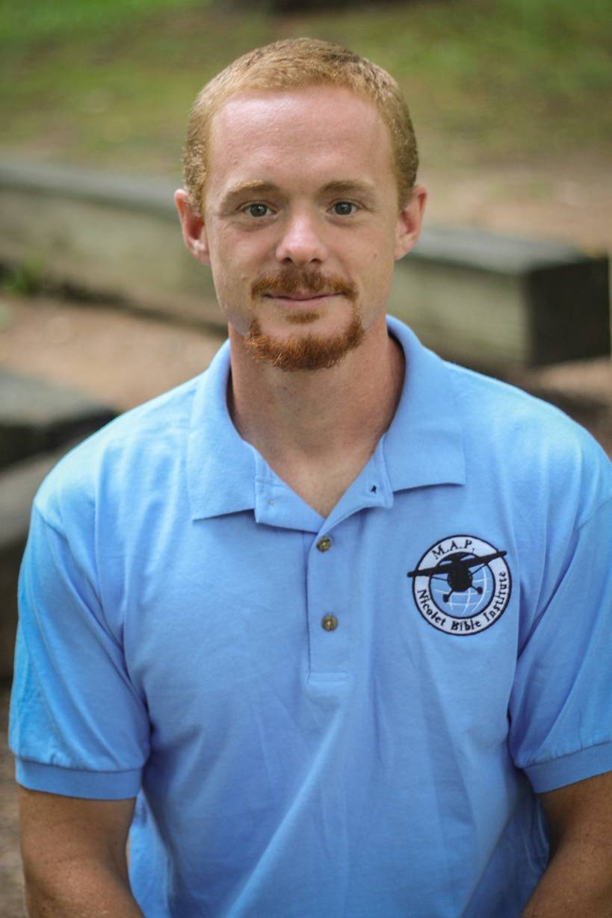

Troy A. Beaber
Nicolet Bible Institute
M.A.P. Program Coordinator
(Missionary Aviation Program)

Previously I worked with Faith in action, a group of tradesmen who use the skills God gave them to help missionaries around the world. This is where I really found a love for mission aviation.
Currently I am serving with Nicolet Bible institute, and Silver Birch Ranch, primarily as a carpenter. I also was the catalyst to starting a mission’s aviation training program here at NBI. I attempted to get into mission aviation and found the path very unclear and the cost very high. These frustrations caused me to start a program that focuses only on training individuals who want to go into missions. NBI has long been training individuals in the core Bible courses and training the whole person in true Christian service. NBI, Dawson Aviation services and SMAT have partnered to put the whole program in a clear path and have done everything we can to keep the cost down and the quality high.
I am currently seeking to get to be a CFI (with Dawson Aviation Services as my trainer) so we can continue to offer this program for years to come.
My wife Jana and my three sons, Tate, Seth and Wyat are Gods gifts to me here on earth.

