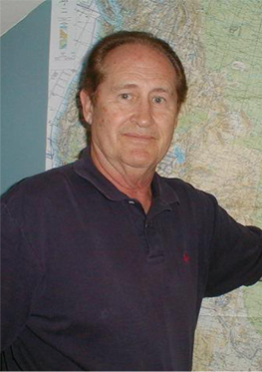
Glenn Dawson
Nicolet Bible Institute
M.A.P.
(Missionary Aviation Program)
When I sit back and consider the significant events of my past, the important aspects of my current life, and my future goals, the underlying theme is one of appreciating the Lords Grace in my life.
I was born and raised in Gary, Indiana, the product of a father with roots in Illinois & Michigan, and a Godly mother with Missouri ancestry. In my senior year of high school, I accepted Christ as my personal savior through “Youth for Christ”. After graduation, I knew I wanted to serve the Lord for the rest of my life and to be a missionary pilot. After high school graduation, I worked at several jobs to pay for Flight Training and Moody College. After receiving my Flight Instructor Certificate, I worked part time at Aero-Tech Flight School instructing; later to become Chief Flight Instructor. I thought the Lord would use me in full time missionary work however, the Lord had other plans for me.
All the years flying commercial, the Lord used me as a Youth Pastor in two churches, as an elder, deacon, Sunday School Teacher, Youth Councilor, and Pastor. I have been blessed with my wonderful wife Krystyna, two sons, one step-son, one step-daughter, and six grandchildren.
My ministry since moving to Wisconsin is Pastor at New Hope Community Church.
Last year Dawson Aviation had the opportunity to partner with Nicolet Bible Institute to assist them in starting a flight training program for missionary pilots. It is these two ministries that now consume my thoughts and visions. First, that I follow the leading of the Holy Spirit in my serving the people at New Hope Community Church in Antigo, Wisconsin. Secondly, my prayer is that God will use the Missionary Aviation Program [MAP] at Nicolet Bible Institute to provide Bible believing servants to become trained pilots, mechanics and other support personnel for many missionaries in need.
Young people today are making career decisions earlier in life. With the advent of the Internet and availability of information, everything moves faster for them.
It is my vision that MAP will provide men and women to serve on the mission field in the future. May God bless our efforts for the Kingdom.
Contact Information: 715.350.9291; gsdawson7@aol.com

