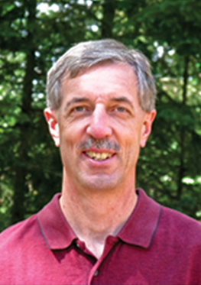
Richard H. Hess
Nicolet Bible Institute
M.A.P. (Missionary Aviation Program)
N6120 Sawyer Lake Road
White Lake, WI 54491
(715) 484-2742 x226
Email: rich.hess@nicoletbibleinstitute.org

Current Role – Dean of Students

  - ___________________________________________

Nicolet Bible Institute, White Lake, WI 1996-present
Teach Courses: Bible Study Methods/Hermeneutics
Missions / Evangelism
First Aid/CPR/ AED
Oversee all NBI students enrolled in our one year program.
Oversee summer guy and girls staff directors.
Oversee all summer volunteer support staff.

Education

New Tribes Mission Language Institute
Camdenton, MO December 1981
Trained in linguistics along with general preparation in phonetics,
phonemics, translation, and cross cultural studies.

New Tribes Mission Training Center
Fredonia, WI December 1980
Theological studies and training in the area of church planting.

Doctor of Chiropractic
National College of Chiropractic
Lombard, IL December 1977

Bachelor of Science, Biology
Ursinus College, Collegetown, PA May 1974

Previous Experience – Tribal Missionary

New Tribes Mission, Colombia, S.A. 1982-1991
Involved in contacting a primitive jungle tribe which had never heard the
Gospel of Jesus Christ. Served primarily as the linguist for the team,
which also entailed language and culture acquisition. Served also in areas
of medical, agriculture and trade. The of entrance and supply was by
small aircraft.

Church Membership

Antigo Community Church, Antigo, WI

Emmanuel Bible Church, Berwyn, IL

