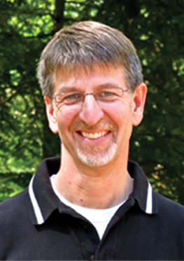

Steven Sanford
Nicolet Bible Institute
M.A.P.
(Missionary Aviation Program)

Home Church: Antigo Community Church-Elder

Places of ministry:
Powderhorn Park Baptist Church, Minneapolis, MN – Youth Pastor, 1981-1985
Associate Pastor, 1985-1988
Silver Birch Ranch, White Lake, WI – Director of Camping Ministries, 1988-2009
Nicolet Bible Institute, White Lake, WI – Academic Dean, Oversee M.A.P., 2009 to
Present.

Education:
University of MN – Bachelor’s in Biology, 1980
Bethel Seminary – Master of Divinity, 1985; Doctor of Ministry, 2003 (Marriage and
Family Studies)

Personal:
Married to my best friend and ministry partner, Becky, for 28 years. We have three
grown children, Brianna, Cameron and Caleb.

Contact:
Nicolet Bible Institute – 714.484.2322 x223
steve.sanford@nicoletbibleinsititute.org

