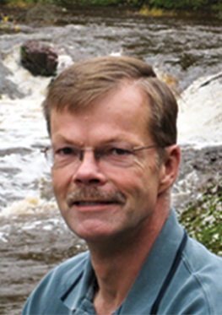

Dave Wager
Nicolet Bible Institute
M.A.P.
(Missionary Aviation Program)

Since 1981 Dave Wager has served as a leader, friend, and teacher to thousands who have entered the educational grounds of Silver Birch Ranch in White Lake, Wisconsin.
Dave continues to serve as the president of Silver Birch Ranch and The Nicolet Bible Institute and teaches at camps, colleges, conferences, churches and businesses throughout the world. Dave is an award winning author (GraceAcresPress.com) who has dedicated his life to communicating the truths of the Bible to students and adults in a simple, energetic and challenging way and can often be heard as a guest or host on various Christian talk radio programs.

Dave has been active serving our nations’ youth in some capacity since 1970 and has a passion to catalyze mentoring programs in our local churches. He is available for filling pulpits, teacher institutes, conferences and consultation.
Contact Information: 715.484.2322 x233; dave.wager@nicoletbibleinstitute.org

