John & Mary Lou Martin
New Tribes Mission

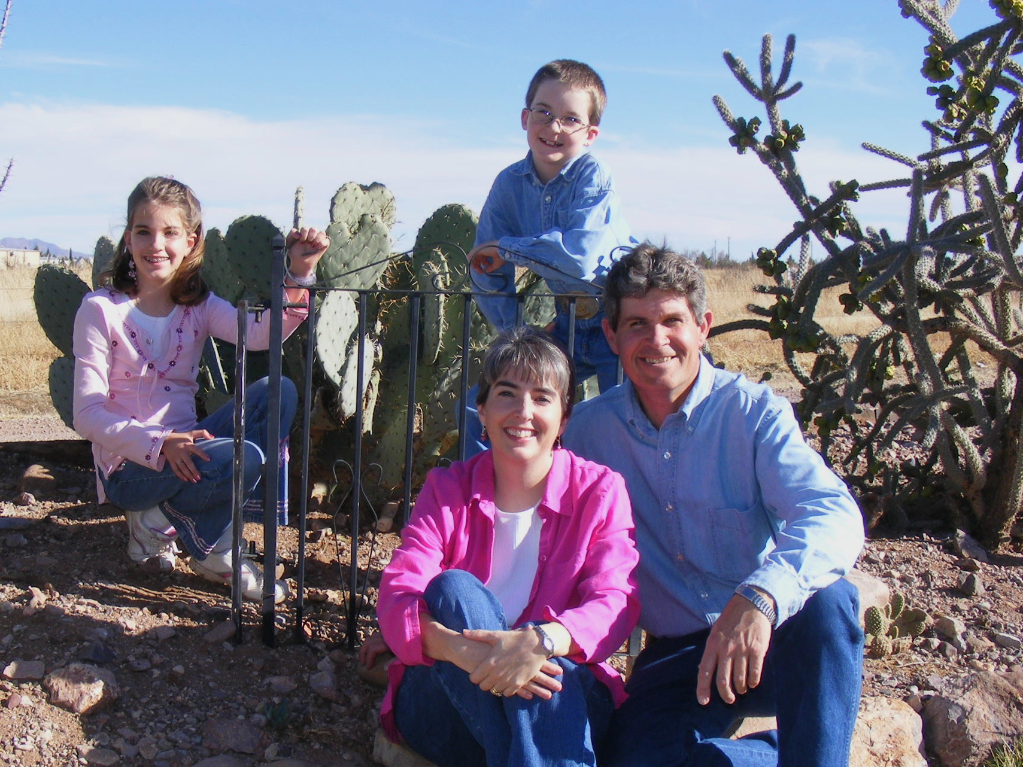
John was born and raised in Brazil, South America, where his parents were missionaries with Child Evangelism Fellowship. As a young child, his interest in aviation was sparked by a helicopter ride with his uncle, who owned a helicopter business in California. John attended Prairie Bible Institute, and then worked at a variety of jobs before gaining his A&P license through Colorado Aero Tech. He then worked at Phoenix Sky Harbor and later Scottsdale Airport to gain experience before joining New Tribes Mission.

Mary Lou is also a missionary kid, but lived in the United States all her growing up years. Her father, Forest Estelle, was one of the co-founders of New Tribes Mission Aviation, and he worked with them until his retirement. Mary Lou attended New Tribes Bible Institute in Jackson, MI, then went on to obtain a B.S. in Elementary Education from Southwestern College in Phoenix, AZ.

John & Mary Lou met on a blind date in Phoenix in 1992, were married in 1993, and began training with NTM later that year. They went to Papua New Guinea in 1995, where they served until 2007, at which time they transitioned to NTM Aviation’s headquarters in McNeal, AZ, to be close to Mary Lou’s parents in their elderly years.

John & Mary Lou have two children – Michaela (11) and Chad (9), whom they home-school. As a family, they feel very blessed to have lived overseas and been able to witness first-hand what God is doing in the hearts of people in PNG.

