Daren & Cindy Spence
New Tribes Mission

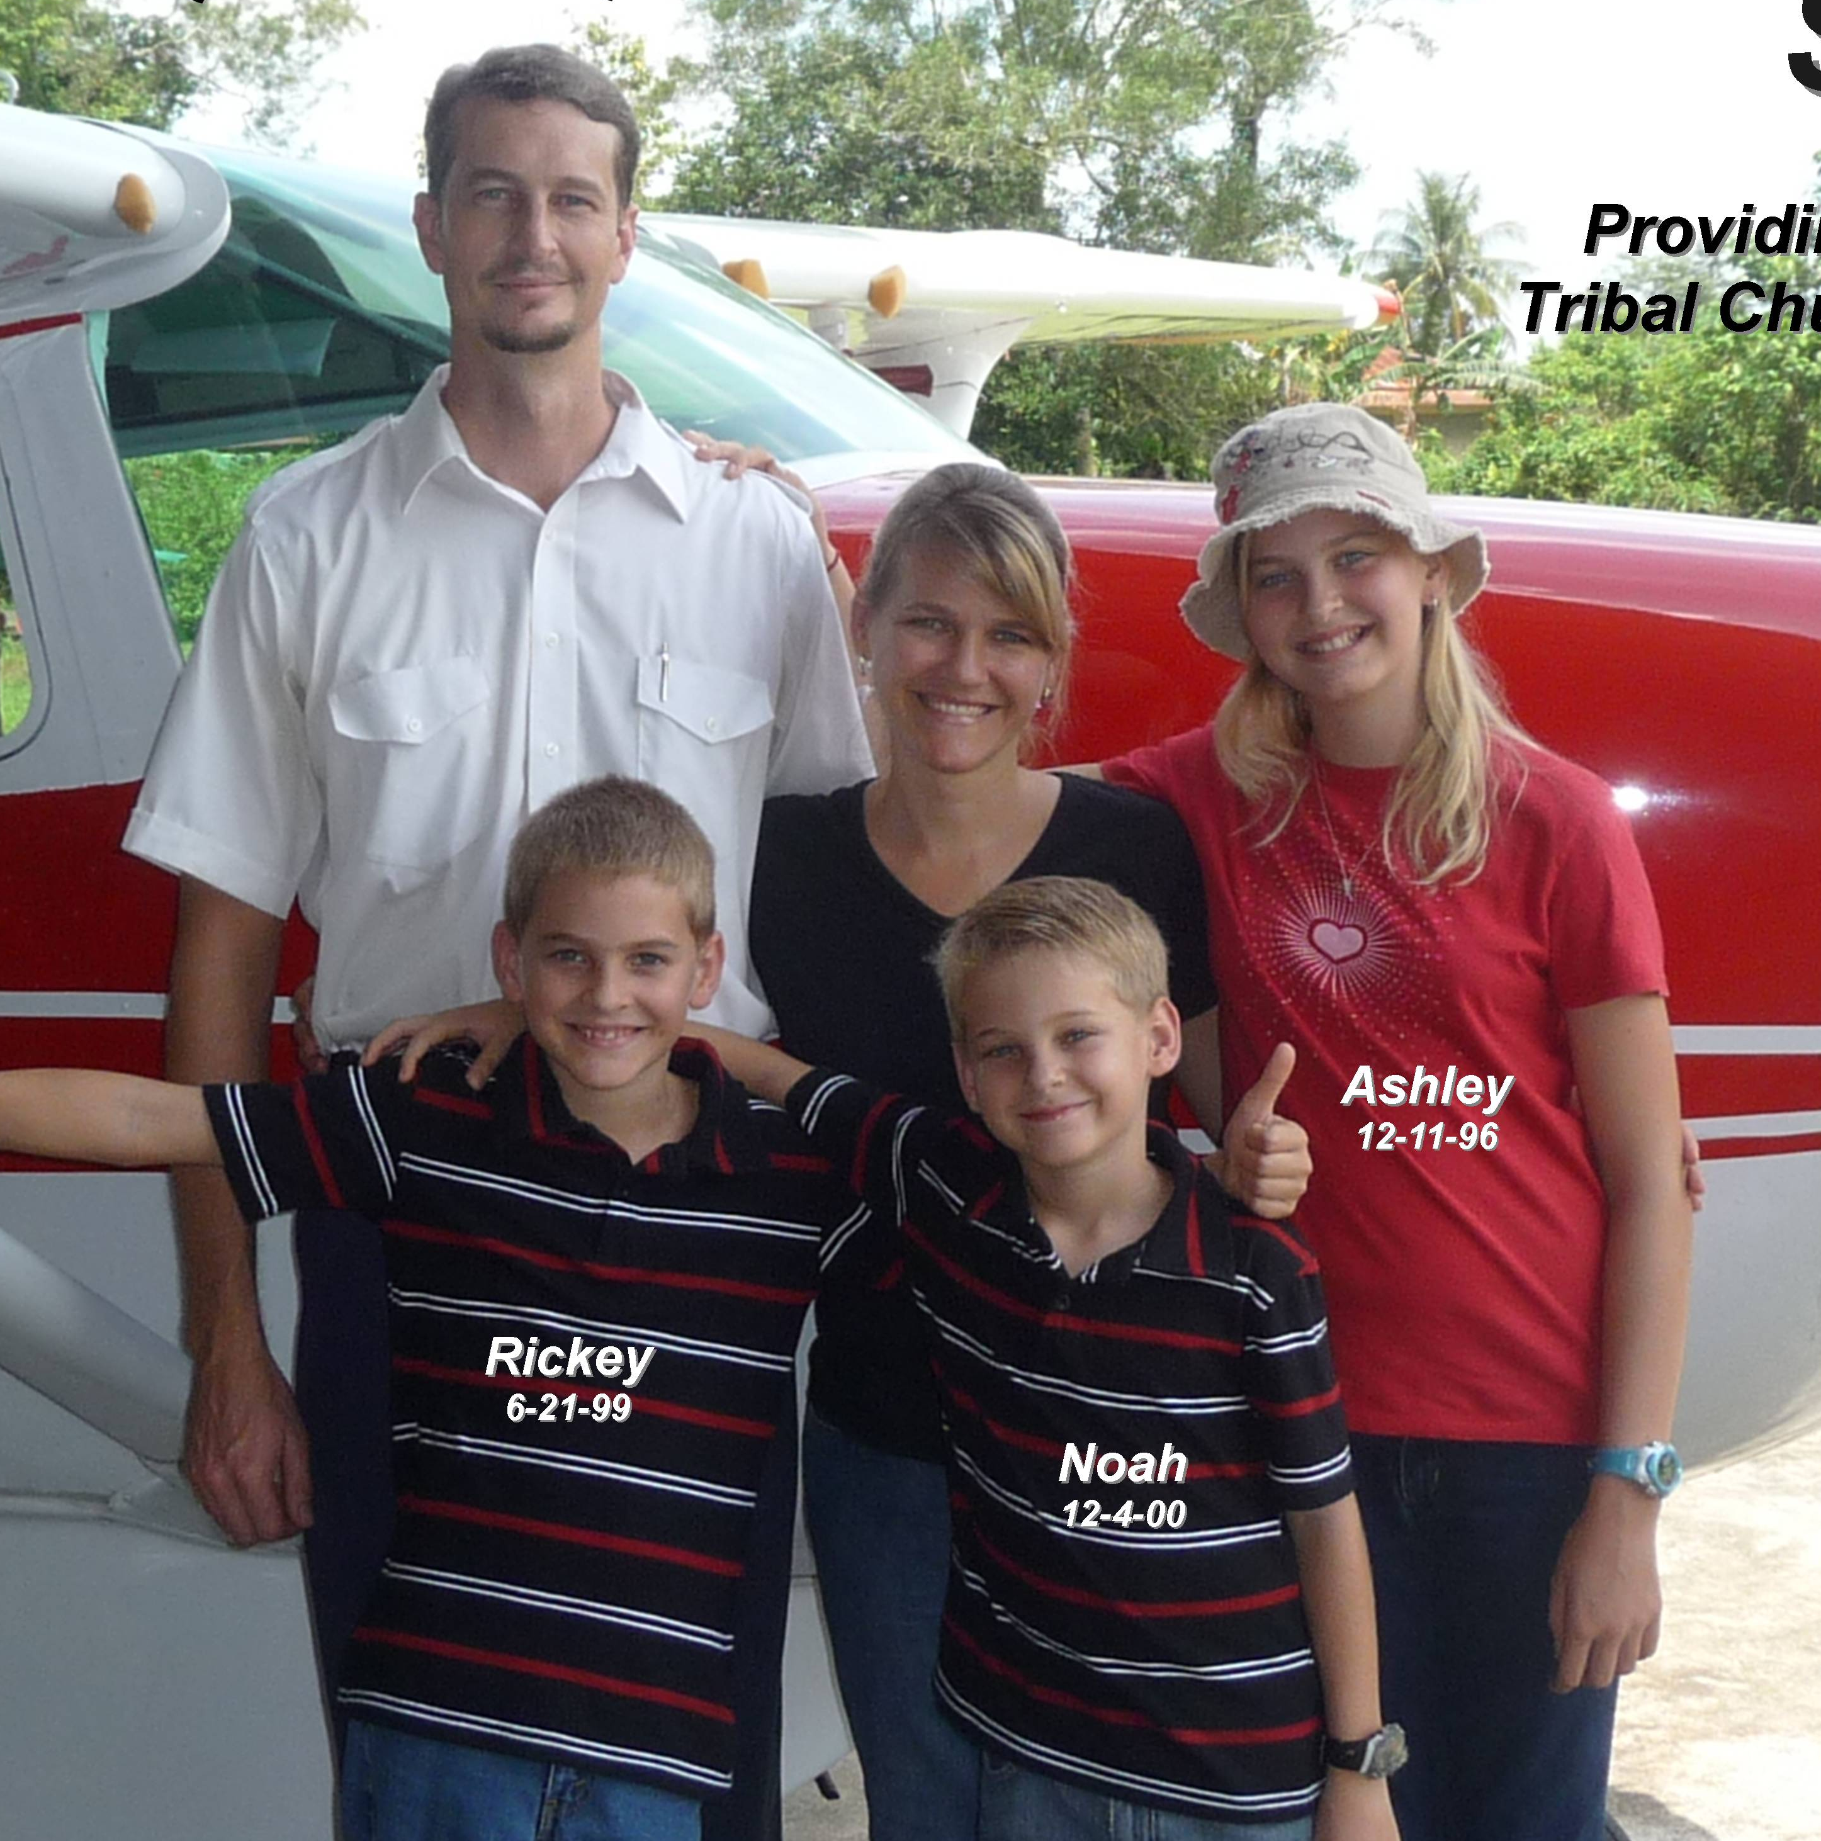
Daren and Cindy Spence are the parents of 3 children, Ashley (12), Rickey (10), and Noah (8). They have served with New Tribes Mission Aviation in Indonesia since early 2005 where Daren serves as pilot/mechanic.

