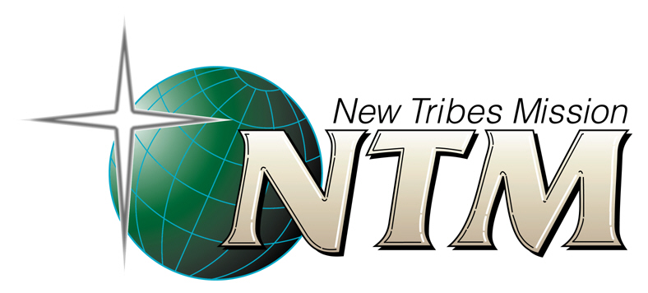

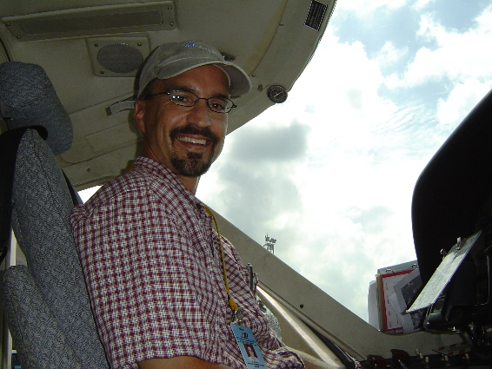
Michael Stroh

Michael grew up in Southern California and was interested in aviation from an early age. He spent many summers in Montana with his aunt and uncle who managed their own FBO and serviced the local farmers with crop dusting and air charter services. While attending college at San Diego State University Michael gained a heart for unreached people groups through his college pastor.

In the spring of 1990 while building flight time Michael took a trip to NTM Aviation’s headquarters in Arizona and saw first-hand how people used their technical skills in aviation to serve missionaries worldwide, reaching people in remote locations with the Gospel. From then on he was hooked. He met his wife Lesley in 1992 while attending Bible School in Michigan.

The Strohs were assigned to Indonesia with New Tribes Mission in 1998. After serving 9 years on the island of Borneo flying in remote areas they returned to the states in 2007. Michael now manages the NTM Aviation Safety Program. Besides managing the safety program for NTMA they love to help facilitate people to make a significant impact with their lives for the reach of the Gospel throughout the world.

Michael and Lesley have three children: Allison age 14, Aiden age 10, and Owen age 7. They presently call Sanford, Florida home and live close to the NTM international headquarters.

