Scott & Mary Wolfe
New Tribes Mission

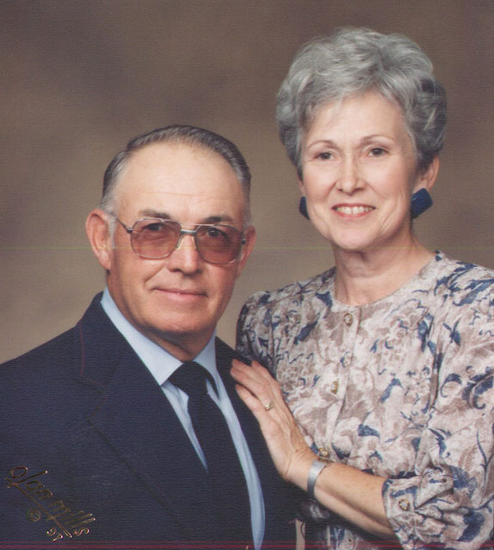
Scott & Mary Wolfe left farming and entered New Tribes Mission in January 1971. After finishing training they drove to the country of Panama to study language and start a flight program for NTM missionaries. After four years they returned for furlough. Before leaving Panama they were asked to go to Indonesia after furlough to start a new flight program. They spent the next 12 years there, starting three flight programs in three different provinces, flying and maintaining three different aircraft.

In 1989 they were asked to move to Arizona and help oversee the flight programs in Southeast Asia and Africa, and train pilots in Arizona. After 18 years training pilots and travelling internationally for three months of every year they are semi retired but continue to be involved at the international offices of New Tribes Mission Aviation.

