Dallas Derksen
Prairie School of Mission Aviation

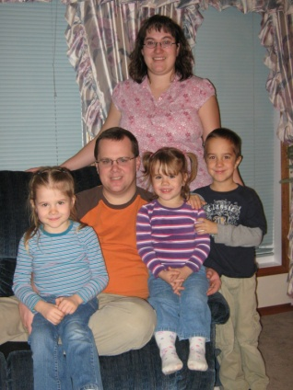
Dallas Derksen was born and raised in Sexsmith, Alberta. He is currently a flight instructor at Prairie School of Mission Aviation (PSMA) in Three Hills, Alberta, Canada. He was called into mission aviation a couple of years out of high school, and has been pursuing that ever since then. He graduated from Peace River Bible Institute (PRBI) in Sexsmith, Alberta, with a Bachelor of Biblical Studies - Missions major. He met his wife Karen there and they have 3 children; Andrew, Katrina, and Jacqueline. After finishing at PRBI they made plans to get his pilot’s licence. In 2004 they came to Three Hills and Dallas earned his Commercial Pilots license and Instructor rating. After this he worked in Grande Prairie, Alberta as a flight instructor at a local flight school for 10 months, building experience. In March of 2008 he returned to Prairie School of Mission Aviation to work as a flight instructor there, hoping to positively impact young pilots as they begin their journey towards careers in mission aviation. In the future they hope to serve in mission aviation wherever they are needed.

