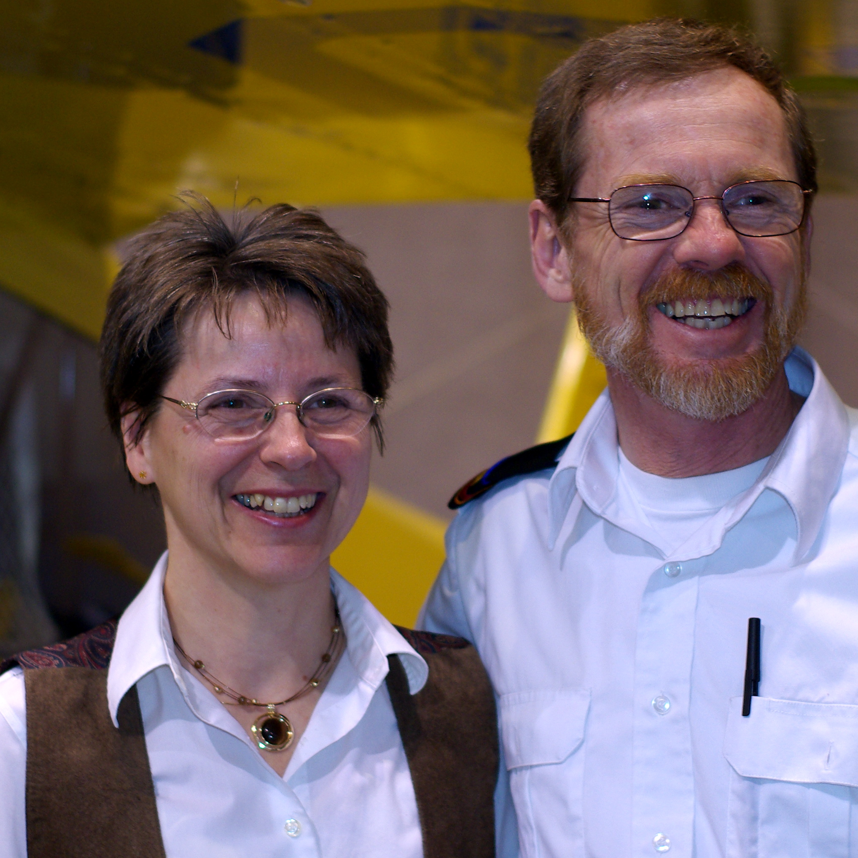

Ron and Jacqui Shaw
AIM AIR
seconded to Prairie School of Mission Aviation

Ron was raised in Richmond, British Columbia, and got his flight training through a local flight school with the intent of flying recreationally. Through an interesting series of events, and three children later the Lord challenged him to consider using his license in a cross cultural setting. With this idea Ron and Jacqui both decided they needed Biblical grounding and left a secure job and home to pursue his Bachelor of Theology at Prairie Bible Institute. Four years later, he continued training at Southern Alberta Institute of Technology, obtaining his formal education for his Aircraft Mechanical Engineer’s license.

In 1992 the Shaw’s left for Nairobi, Kenya to serve with Africa Inland Mission’s air wing, AIM AIR for the next 9 years. During this time AIM AIR was involved with flying into most of the surrounding east and central African nations, as well as within Kenya. It involved supporting mission families in remote locations, serving and flying in several war zones, aiding with evacuations, medi-vacs, and humanitarian aid. As is usually the case with missions, Ron served in several other capacities besides flying and maintaining aircraft: from Parts Room Manager up to General Manager before returning home in 2001, with their 3rd child ready to enter University. Ron’s health suffered, but God has graciously seen fit to enable him to resume ministry.

Jacqui has served as homemaker, secretary, bookkeeper, receptionist, and office manager in various locations as they’ve moved around and thoroughly enjoys these support roles wherever the Lord opens the doors.

They are thrilled to be involved with training young men and women towards mission aviation currently as they reside in Three Hills, AB, and both work at Prairie School of Mission Aviation.

