Rick Willms
Prairie School of Mission Aviation

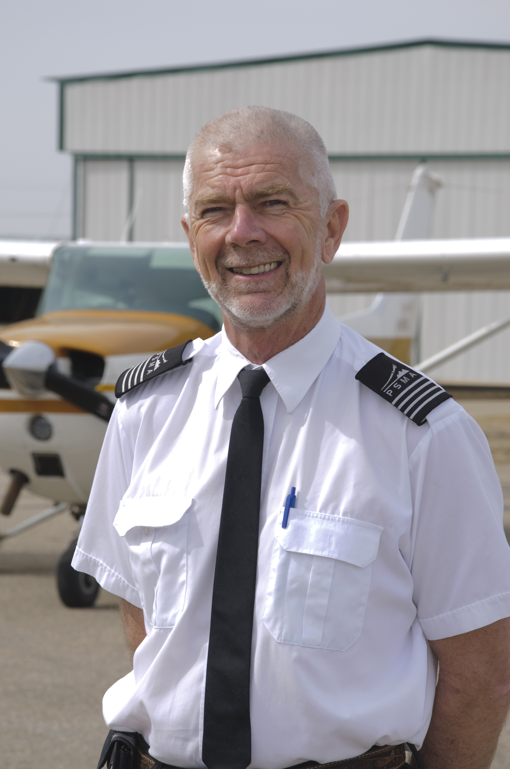
I was born to Mennonite dairy farmers in Western Canada in 1953. My parents took their faith seriously and we attended all the services of our evangelical Mennonite church. This gave me the opportunity to give my heart to Jesus at an early age, felt the call to missions before I was 10 at a Sunday evening service. I watched the presentation of an MAF pilot heading to Irian Jaya, Indonesia when I was 12 and planned to be a missionary pilot after that.

I started my aviation career by getting my Commercial Pilot licence at 19 and immediately went to school for aircraft maintenance after that, eventually becoming an Aircraft Maintenance Engineer. I gained flight and maintenance experience in western Canada and northern Canada.

Started 3 years of Bible school training in 1975 at Briercrest Bible College, got married in 1976 and went overseas with our family in 1981. We spent 24 years in Irian Jaya (now called Papua), Indonesia as a pilot/mechanic with Mission Aviation Fellowship. Our 4 girls grew up in Indonesia, all finishing high school there before coming to Canada.

In 2005 we returned to Three Hills, Canada and I was a flight instructor at Prairie School of Mission Aviation for 6 years. We are presently finishing a sabbatical and looking to work full time at PSMA again.

