NEIL AND BECKY DUBOIS
Biographical Sketch

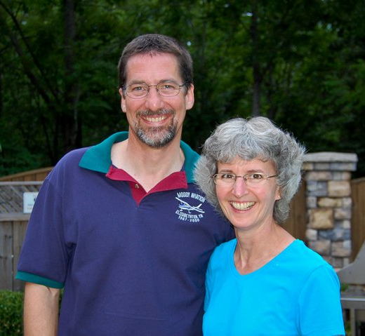

Neil grew up as the son of Wycliffe Bible translators in the Philippines. He frequently stayed in the children’s boarding home when his parents were working in the village. It was there Neil realized his need for salvation and prayed to receive Christ. Following high school graduation in the Philippines, Neil attended Moody Bible Institute where he earned a BS in missionary aviation technology.

Becky grew up in rural Nebraska. She responded to God’s call and surrendered her life to Him following family devotions. Becky attended Grace College of the Bible in Omaha where she felt God’s call to missions. She graduated from the University of Nebraska with a degree in elementary education and went to the Philippines for three years to teach missionary kids.

Neil and Becky met in the Philippines when Neil came home for a short visit. They joined Wycliffe in 1988 and were married in 1989. They returned to the Philippines; Neil serving as a pilot/mechanic and Becky as a schoolteacher. Six weeks after arriving, Neil sustained spinal injuries from a fall and so is unable to handle the heavier types of aircraft used overseas. They returned to America and were assigned to serve at Moody Aviation.

After twelve years at Moody, they continued their work with future missionary pilots in Melbourne, Australia at the Bible College of Victoria. In 2009 they returned to the JAARS center in Waxhaw, North Carolina to serve in aviation training and recruiting. Their current assignment finds them in Ionia, Michigan where Neil is working in the flight department of the School of Missionary Aviation Technology (SMAT) and Becky continues her recruitment work.

