Pauline Brothers
Spokane Turbine Center

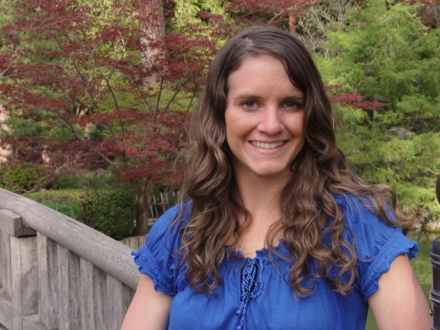
I was born into a Christian family on the night of a huge blizzard, and grew up in the backwoods of North Idaho. I fell in love with the outdoors and was always wandering off somewhere looking for a new adventure. From growing up on a ranch I learned the value of hard work, and the satisfaction of doing a good job. When I was old enough I joined a 4-H group and showed all kinds of animals at the local fair; while at the same time competing in Gymnastics, and later on the High School swim team.
A year before I began High School, I decided to join our church’s Youth Leadership group. I thought it would be a great place to hang out and have fun. So I was extremely surprised when I showed up the first night to find out that it was pretty much a really intense Bible Study. I honestly hated it and didn’t want to go back, but I couldn’t help returning. I realized that each of these people had something different about them…a personal relationship with God, and they could read and understand the Bible. I decided I really wanted what they had, and I dedicated my life to God and to His work. It was then as though I had climbed onto a train going 100 mph in the opposite direction. God was doing a work in my life, and He wasn’t taking His time.
I then began serving at VBS and part time at a Bible camp in the summer. When I was 15 I dropped out of 4-H and decided to serve 2 years as a Summer Missionary Intern with American Missionary Fellowship. It was during this time I was introduced to Mission Aviation through Prairie Bible Institute. This sparked my interest because it combined my passions…missions/people and flying. I then began pursuing mission aviation and started training at Moody Bible Institute after graduating High School. My time at Moody challenged me in many different ways, and grew me closer to Christ. I graduated May 2013 and went on to become an Instrument Flight Instructor. I am now serving at Spokane Turbine Center, and am excited to see where God will lead me in the future and what doors He will open!

