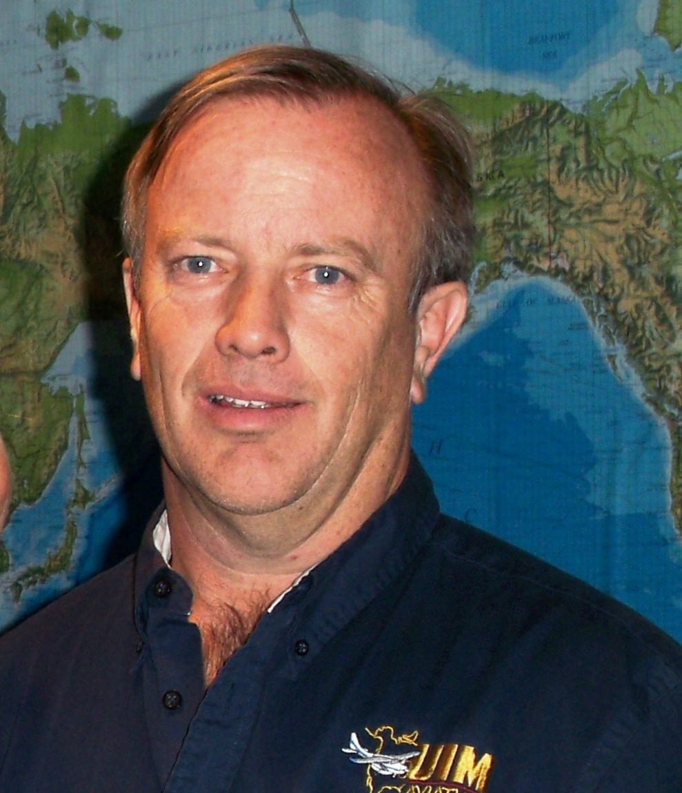

Tim Reid
UIM Aviation

In 1996, Tim was an owner of two successful TV and Appliances Stores in NW IA. His three children were in middle-school. Tim answered God's call on his life for full-time missions. He sold his business and moved his family to Winston-Salem, NC to attend Piedmont Baptist College,

After completing his degree in aviation, Tim stayed at PBC and taught the A&P program and gave flight instruction for three years. In 2004, Tim and his wife, Ginnie, joined UIM Aviation. He is currently serving in Tucson as the pilot and assists with maintenance as well. All our flying is done in Mexico and primarily in the Sierra Madre Mountains. UIM Aviation partners with various mission organizations in Mexico that have missionaries living in remote villages in the mountains.

