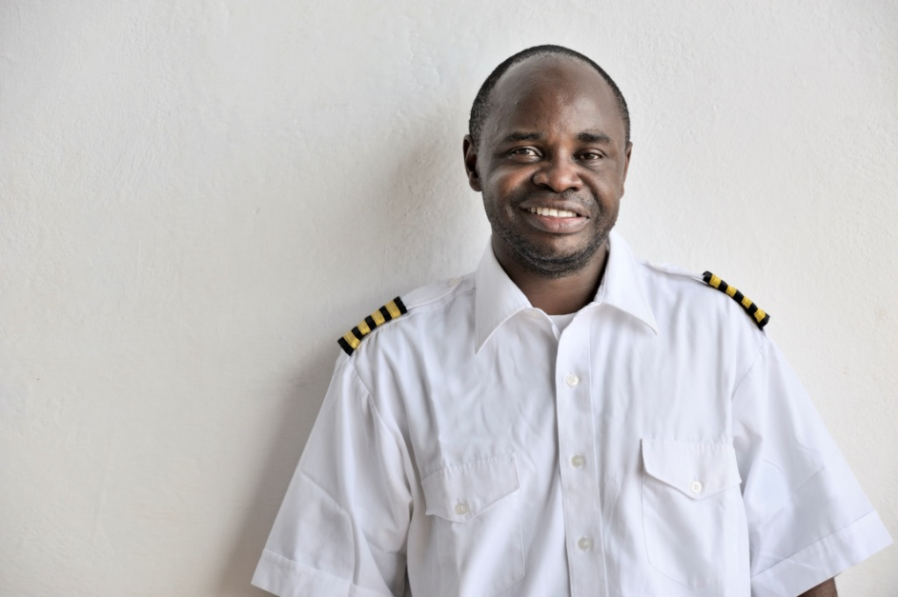

Rukang D Chikomb
UMAM

Rukang D. Chikomb is a missionary with the General Board of Global Ministries of The United Methodist Church. He is currently director of Southern Congo Wings of the Morning, the aviation ministry of the Southern Congo/Zambia Episcopal Area. Southern Congo Wings of the Morning provides transportation for hospitals, educators, mission teams, church leaders, and other mission needs.

Born in Lubumbashi in the Democratic Republic of Congo (DRC), Rukang attended local United Methodist schools and earned a state diploma in chemistry and biology. He worked for Southern Congo Wings of the Morning as aviation mechanic aid and public relationship assistant from 1991 to 1999.

Rukang graduated in 2002 from Moody Aviation, then in Elizabethton, Tennessee, a part of Moody Bible Institute of Chicago. He subsequently earned a certificate from the Federal Aviation Administration (FAA) as a commercial pilot, mechanic, and FAA inspector. In 2010, he graduated from Eastern New Mexico University at Roswell with an Associate of Applied Science degree in aviation maintenance technology.
He maintains close ties with the Holston Annual Conference and Wesley Memorial United Methodist Church in Johnston City, Tennessee, where he is a member.
"I am so blessed to be a part of the ministry serving God's people in Africa and around the world," he says. He recalls with gratitude the influence of an aunt on his spiritual and professional life when he was growing up on the Kapanga United Methodist mission base. "We can only give back to God if we listen, accept, and obey his call to witness Him in this World."
Rukang was a French interpreter at the 2004 and 2008 General Conferences. He worked with United Methodist Communications in equipping supplies for Africa Central Conferences' communications offices, and has worked with the Division of Ministry with Young People of the General Board of Discipleship as a travel consultant, and as interpreter for the Congo Central Conference youth delegates.
He is married to Fresie Chikomb. The couple has three children: Andre, born in 2000; Sally, born in 2001; and Selena, born in 2007.

