GASTON NTAMBO
United Methodist General Board of Global Ministries (GBGM)

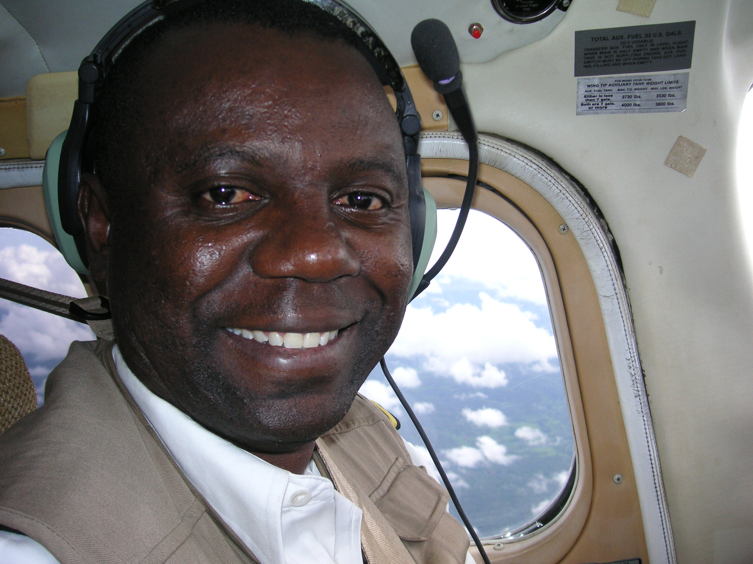

Gaston Ntambo is a missionary of the General Board of Global Ministries of the United Methodist Church assigned to the Democratic Republic of Congo (DRC). Based in Lubumbashi, Gaston serves as a pilot and mechanic with the Wings of the Morning flight ministry in the North Katanga Conference.

The aviation ministry provides transportation in hard-to-reach areas of Africa, especially in emergency situations. Reflecting on his work, Gaston says, “I believe God is using me as a tool to reach out and save lives.” He recalls that he once flew unknowingly into a war zone in an attempt to rescue missionaries stranded there. “I was surrounded by soldiers and put under house arrest,” he reports. But it just “so happened” that the highest officer in the village that day happened to also be an uncle that I had never met. “Out of nowhere, he suddenly introduced himself to me for the first time and secured our release.”

A native of Kamina, DRC, he earned associate degrees in accounting and piloting from Davis College in Toledo, OH. He received a mechanic's certificate from the Michigan Institute of Aeronautics in Detroit. Prior to his commissioning as a GBGM missionary, Gaston worked six years as a Wings of the Morning pilot. Gaston is married to Jeanne Ntambo, also a GBGM missionary and they are parents to five children.

