STEPHEN QUIGG
United Methodist Aviation Ministries (UMAM)
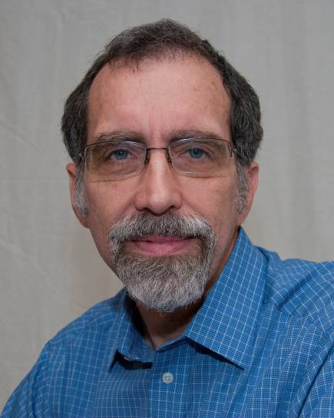
Serving as the Aviation Coordinator of the United Methodist Aviation Ministries, Steve is able to transform twenty years of mission aviation experience into practical logistical and technical support for the United Methodist pilots working in Congo. While the Congolese United Methodist Churches are justifiably proud of their completely nationalized aviation programs, there are still plenty of challenges to overcome. The Congolese pilots often don’t have the financial backing, technical support network, or specialized training that a Western missionary pilot typically brought to the job. Steve helps bridge that gap by being a liaison with mission leaders, providing maintenance support, supplying important safety services, and purchasing spare parts and supplies.
Steve earned a degree in Aviation and Electrical Engineering Technologies from LeTourneau College, completed advanced flight and maintenance training at Moody Aviation, studied cross-cultural ministries at Asbury Theological Seminary, and completed a computer science minor equivalent from Asbury College. He is also a commercially rated pilot, a certificated flight instructor, and an Airframe and Powerplant mechanic.
Steve and his wife Gail began their missionary career in 1979 in the small village of Bambur, Nigeria, where they worked with Air Muri - the aviation branch of the Nigerian United Methodist Church. The Quiggs’ next assignment was in the Democratic Republic of Congo (formerly Zaire) with the “Wings of Caring” flight ministry of the Central Congo Annual Conference where Steve served as a pilot and the Director of Maintenance. However, with civil war in Congo shutting down the church aviation programs, the Quiggs returned to the States to begin their present assignments with UMAM and Mission Safety International.

