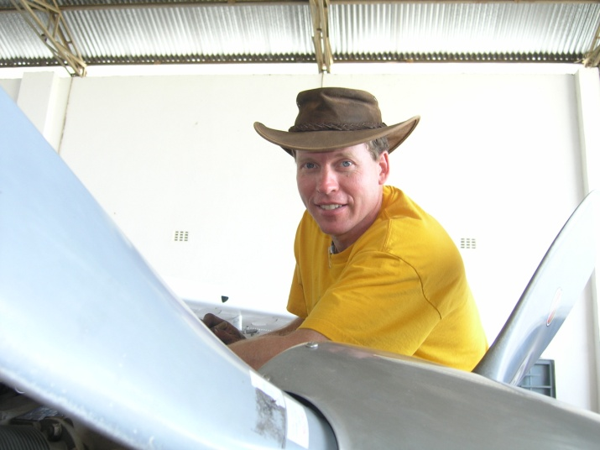
Don Woodward
United Methodist Aviation Ministries

The years that Don Woodward and his family spent in the Democratic Republic of the Congo (DRC) flying airplanes for the United Methodist Church were relatively few in number but they very exciting nonetheless. The DRC was going through a very nasty and tumultuous civil war in the late 90s, and while the active fighting was a long way from the United Methodist Aviation Ministries (UMAM) bases, the war deeply affected the entire country. Don’s flying helped to bring hope to the people in the South Congo region during the war years by keeping the rural churches and villagers in contact with the outside world. Church leaders, relief supplies, medicines, and patients were regular “passengers” on his plane.

The war came particularly close to Don when his aircraft was commandeered by local military authorities to conduct surveillance flights for the war effort. As soon as those flights were done, Don arranged to smuggle the aircraft and his family out of the country to safety in a neighboring country.

After his assignment in the DRC, Don taught aeronautics and flight instruction at Hesston College in Hesston, Kansas and currently is the manager of the Cessna Employees Flying Club for the Cessna Aircraft Company in Wichita, Kansas.

