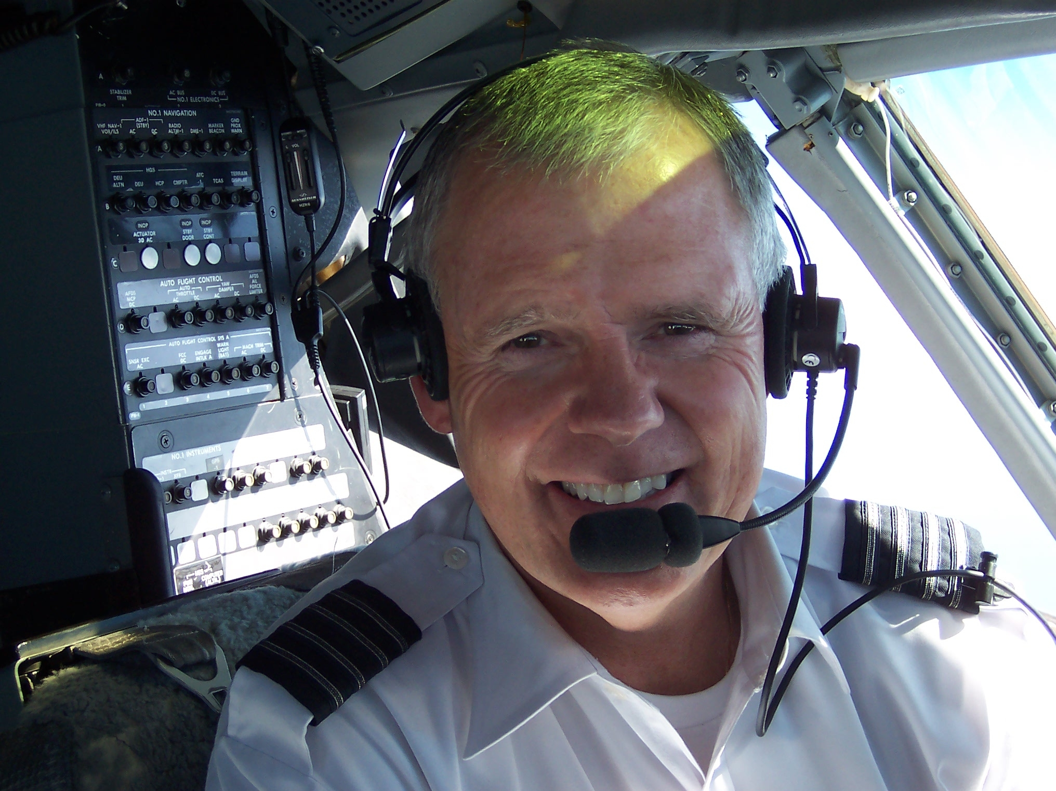
Ted B. Leenerts
Wings of Faith

Mr. Ted B. Leenerts has over forty years of extensive aviation experience within the military, general aviation, and airline sector. Following college graduation from Arizona State University with a Bachelor of Science Degree (Summa cum Laude) in Aeronautical Technology, Mr. Leenerts served as a pilot in the US Navy. He since has flown as an Instructor Check Airman, corporate pilot, production test pilot for McDonell – Douglas, and currently as an airline pilot since 1977, and a Captain for a major airline since 1983. In addition to his 27,000+ hours of flight experience and numerous Airline Transport ratings and Instructor licenses, he is an aircraft owner and is licensed as an Airframe and Powerplant Technician.

Twenty years ago, Captain Leenerts answered the call to pursue Christian ordained ministry as a concurrent profession to compliment his airline career. Returning to graduate school, Captain Leenerts earned a Master Degree of Psychology from Pepperdine University; a Master of Divinity and a Master of Theology Degree from Fuller Theological Seminary; and a Doctorate of Ministry Degree from Gordon-Conwell Theological Seminary. He is an ordained minister in the Presbyterian Church and has worked as a Pastor, Counselor, and Police / Fire / and military Chaplain.

In 2003, Dr. Leenerts was the recipient of an honorary Doctorate in Humanities from Pepperdine University for his chaplaincy work at Ground Zero immediately following the attacks of 911. In 2004, he was also the recipient of the Alaska Airlines Legend Award for his contribution to Critical Incident Stress Management and pastoral counseling for victims of aircraft accidents.

Today, in addition to his airline and ministry career, Ted is the founder and president of “Wings of Grace, Inc.,” an aviation ministry transport company dedicated to humanitarian airlift. He has been instrumental in the support and development of several non-profit aviation ministry efforts both locally and at the national level, and currently is a board member for Wings of Faith. He is currently on a military leave of absence from the airlines having been recalled back into the Navy as a Chaplain based at Camp Pendleton with the Marines. Ted is married and resides with his wife in Coto de Caza, California.

