August Swanson
Wings of Faith

A former Vietnam combat pilot, August Swanson is now a leading strategic planning and business development professional with an exceptional background in military and general aviation.

August possesses an Airline Transport Pilots license in multi-engine airplanes, multi-engine seaplanes and helicopters. He has been involved in the planning and marketing of aircraft for both Piper and Sino Swearingen Jets. In addition, August has a broad background in biometric and acoustic sensors, and aerial security platforms such as UAVs and geosynchronous airships.

August is a former board member and director for Transbiotec, an Irvine, Calif., firm that markets an alcohol detection and blood/alcohol monitoring system which he helped develop for the aviation, commercial transportation and OEM automotive industries. As the former president and chief pilot of the Orange County (Calif.) Search and Rescue response team, he managed the growth, training and deployment of the team to California emergencies - such as the Northridge earthquake. A partner in Willigent Technologies, August also consults on the strategic business development, marketing and deployment of the companies “Wide Area” advanced acoustic security system.

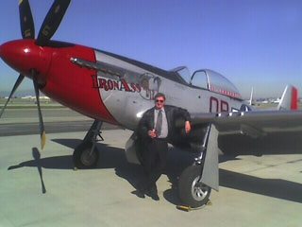

A trained and certified mountain rescue specialist and EMT, he contributes his voluntary efforts toward medical and relief missions around the world and the planning of community emergency response teams. He is a graduate of the prestigious Pepperdine University School of Business in Malibu, California
August R. Swanson
WARBIRD CONNECTION
www.warbirdconnection.com
airboss@warbird connection.com
Phone: 951-789-4000
Mobile: 951-858-4055

