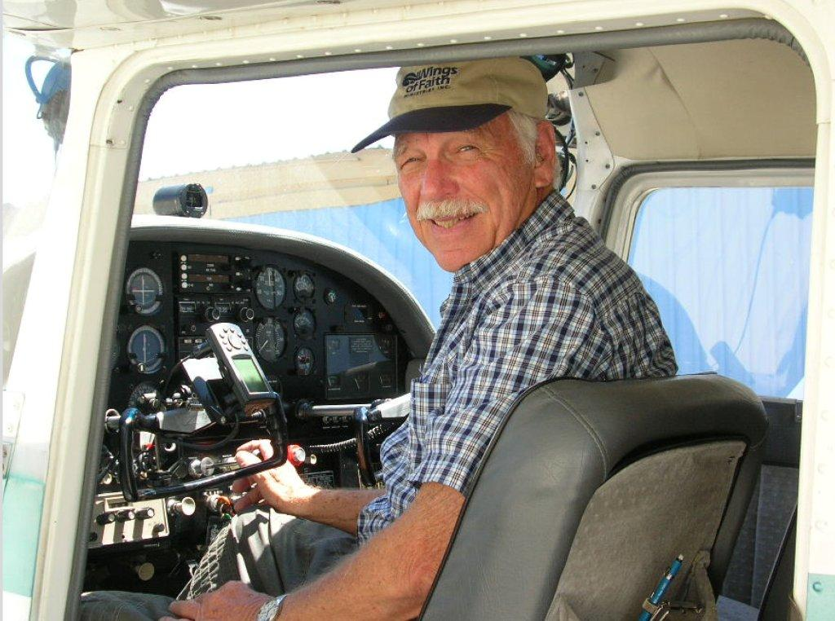

Dale Whinery
Founder of Wings of Faith Ministries

Dale still serves as President of Wings of Faith and has served in Missions for more than 30 years, flying for various secular and mission organizations until the founding of Wings of Faith in 1976. Dale is an ordained minister and has ministered to thousands with the Word of God.

Dale has dedicated his life to reach the unloved, unwanted, and unsaved in areas of the world mostly where there are no churches or where the Gospel may have never been preached. There were opportunities to minister in small villages using Gospel Films and generators mounted on special off road equipment. He has plowed into the bush country in search of the lost.

He has distributed thousands of Bibles, tracts, teaching tapes and other Gospel material in native languages as well as reaching out to the needy with food, clothing and other material as needed.

Wings of Faith has dedicated itself to support and supply missionaries located in remote areas with the use of light aircraft and off road vehicles serving mostly Mexico and the American Indians. They ministered to a lost and darkened world, and helped meet any spiritual, emotional, physical, or material need that came up.

