**John Pepper**

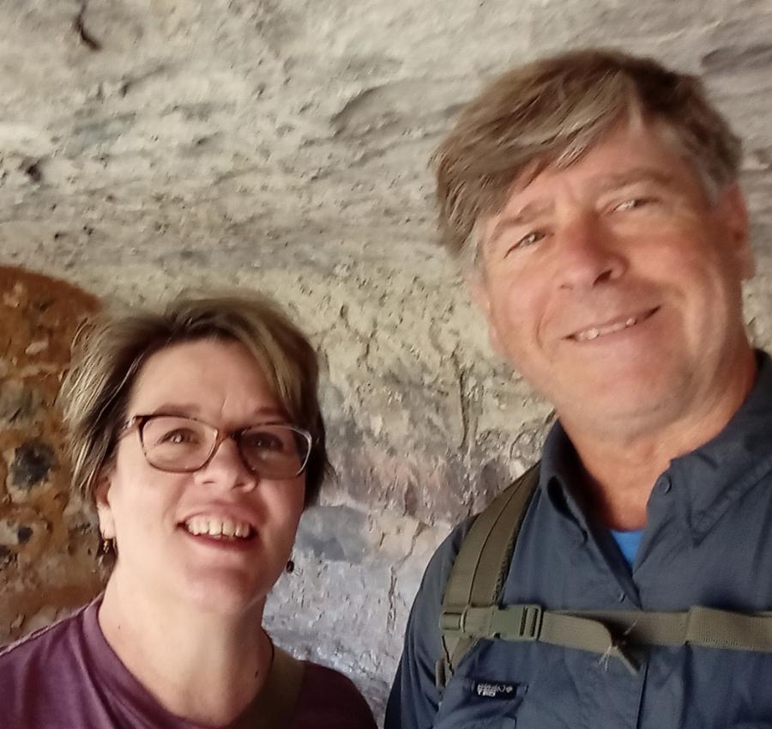

I had served in the Ivory Coast my first term. I am currently the lead 4x4 driving instructor, motorcycle safety instructor, and Water Travel Safety instructor. I served 4 years in the Navy. I enjoy riding motorcycles, driving cars and off-road vehicles, playing basketball and surfing.