**Anna Lehr**

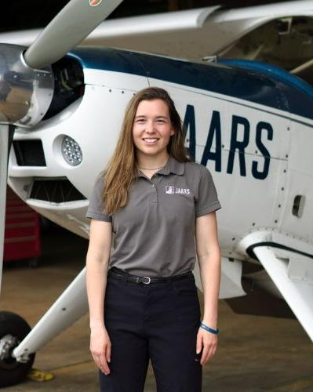

My name is Anna Lehr and I am from Michigan. I graduated Mid Michigan College in 2020 with a degree in graphic/web design. After taking a break to work full time, I attended the School of Missionary Aviation Technology in 2022-2024, graduating with my airframe and powerplant maintenance certifications and as a commercial pilot. I joined JAARS in the fall of 2024 and will be a flight coordinator in their PNG base next year. When I’m not flying or planning flights I enjoy fishing, walking the beach, endurance running, most sports, and quilting.