**Derric McElheney**

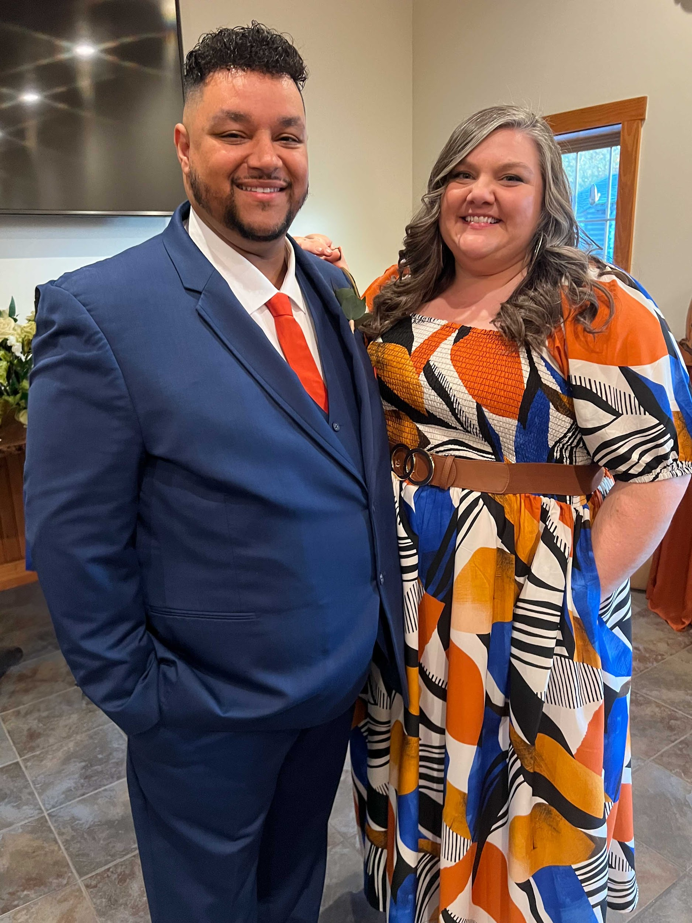

Derric McElheney – Major Gift Officer, JAARS  
  
Derric McElheney serves with JAARS, a ministry that covers the last mile of missions—using special-purpose aircraft, boats, and off-road vehicles to help Bible translators and missionaries reach some of the most remote places on earth. These are places beyond airline flights, boat charters, or bus routes—where people are still waiting to experience God’s Word and his love.  
  
As a Major Gift Officer, Derric connects passionate believers with global efforts that have an eternal impact. In 2024 alone, JAARS supported over 6,700 field flight hours and transported more than 22,000 aviation passengers, ensuring translators and mission workers can focus on the work God has called them to do.  
  
  
Derric’s deep love for Jesus drives everything he does. His goal is to stir hearts toward generosity and action, so every language group has the chance to hear and understand the hope of the gospel.