about 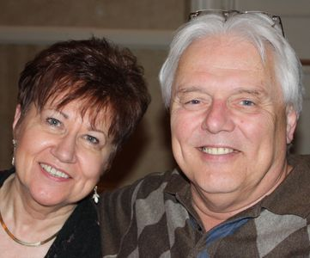

Bernie & Jo Koszewa Former Executive Director

We have both accepted Christ as our Lord and Savior and followed the Lord’s leading in baptism . We both were blessed to have Christian parents. My father served as church moderator and Jo’s father served as a deacon. Our family lives revolved around family and church, activities.

While serving in the Army in Thailand, I became involved with the Overseas Christian Serviceman’s Association keeping me close to the word of God. After military service Jo and I were married in our home church in Milwaukee in 1970.

Jo is an alumni of North American Baptist College (now Taylor University) and toured the US and Canada with Gods Volunteers a music and ministry outreach. We have both served actively in various church related roles and responsibilities putting God first in our lives. God blessed us with two children who are now actively serving the Lord in their home churches. God has shown us numerous times not to judge what happens when there are difficulties in life and problems we think are insurmountable, that in fact God allowed these circumstances to pull us closer to Him.

Like with many Christians, numerous doors have been opened and shut in our lives, not always to our understanding at the time but always there was a clear picture and blessing associated with each circumstance.

Semi-retired now and Jo close behind has given us the opportunity to reflect on God’s impact to our personal lives and those around us. Considerable time in prayer was spent about where to go from this point forward to serve Jesus.

Our understanding is to live as a disciples of Jesus Christ and to accept what God has given us in the way of talents and blessings and to apply them as He leads. Acceptance of God’s will has shown us that God’s word needs to be shared with others even though we may never see the result of that interaction. Discipleship to us many times means denial and changes in life that sometimes are uncomfortable but serve to further the Kingdom of God.

We are both grateful and honored to have this opportunity to carry forward the MASA ministry that Lee and Debbie have put so much of their lives into.

We have both accepted Christ as our Lord and Savior and followed the Lord’s leading in