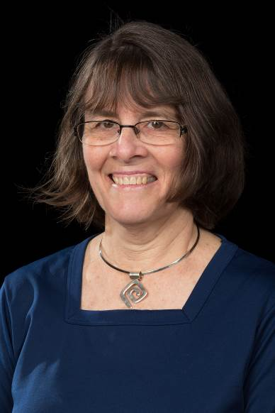
Gail Quigg
Mission Safety International

Although now officially retired after a forty year missionary career with Global Ministries, Gail considers her life to be a never-ending quest to follow Christ and to serve Him in ministry. Her passion for people is evident in the way she touches people’s lives with care and compassion whether it’s visiting a hurting soul around the corner or a missionary family half way around the world.

Gail’s missionary work has been as varied as the countries where she has worked. In between flight following the plane and chasing down her 2 daughters, she has taught community-wide Bible studies, maintained financial books, and scheduled flights. Working with Mission Safety International has given her the opportunity to make safety presentations, counsel new missionaries, lead women’s events, and share her perspective as a bush pilot’s wife with other women in aviation ministry.

Gail and her husband Steve started their missionary careers in 1979 in the village of Bambur, Nigeria, where they worked with Air Muri, the aviation branch of the Nigerian United Methodist Church. Their next assignment was in the Democratic Republic of the Congo working with “Wings of Caring”, the flight ministry of the Central Congo United Methodist Church. After leaving Congo in the midst of a protracted civil war, the Quiggs started work with Mission Safety International turning their twenty years of missionary aviation experience into practical safety support for missionary aviators everywhere.

When not traveling, Gail and Steve really enjoy being home! They also treasure spending time at the Vermont cabin and/or playing with their grandkids Sami, Kaylee, and Grayson growing up in the wilds of western Kentucky.

gailquigg@juno.com
717-799-8583

