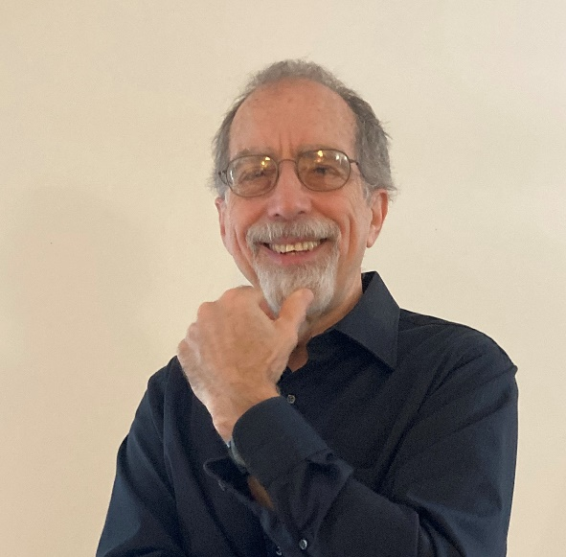**Stephen Quigg**

**Mission Safety International**

Steve is a career missionary serving with Mission Safety International, an organization dedicated to *Making Safety a Way of Life* for missionary and humanitarian aviators around the world. His twenty years of work as a missionary pilot/mechanic in Africa provided Steve with the technical and logistical expertise he now uses to provide practical support for pilots and mechanics working in very challenging environments. As MSI’s Vice President of Field Services, Steve helps provide a variety of safety services including seminars, audits, accident investigations, continuing education events, and safety publications.

Steve and his wife Gail began their missionary careers in 1979 in the village of Bambur, Nigeria, where they worked with Air Muri - the aviation branch of the Nigerian United Methodist Church. Their next assignment was in the Democratic Republic of the Congo (formerly Zaire) working with “Wings of Caring”, the flight ministry of the Central Congo Annual Conference. Gail and Steve are the parents of two grown daughters, Heather and Kathy, both of whom were born in Nigeria.

Contact Info:

squigg@msisafety.org

Cell: 732-252-3303