Craig Talsma
MAF

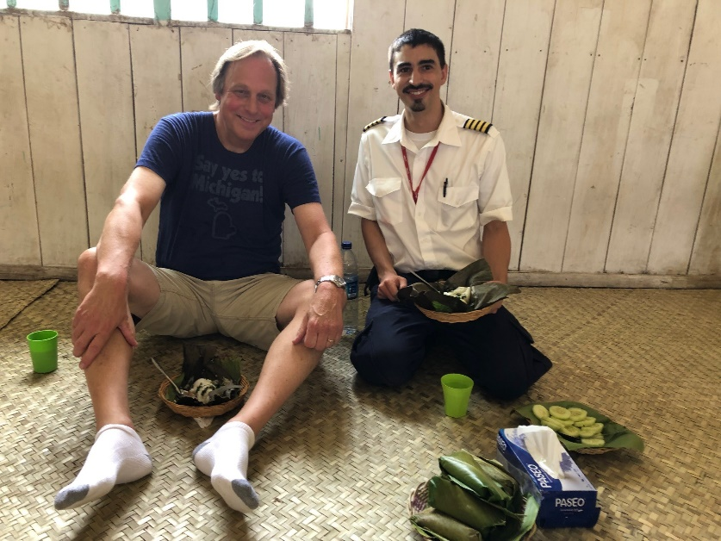

Craig Talsma is a manager of MAF Advocates - volunteers around the northern US - who are tasked to speak to friends and groups about MAF’s mission to reach the isolated with the love of Christ.

Craig was introduced to Mission Aviation Fellowship while taking flying lessons. Craig met two Certified Flight Instructors who were building hours to fly with MAF overseas. Their ambition captivated him. They planned to go to Indonesia with their families and be missionary pilots and mechanics. Catching their enthusiasm for flying and missions, Craig became an Advocate for MAF. He has been blessed with many opportunities to present the MAF story to friends, at churches, schools, and civic clubs.

While an Advocate, Craig made a trip to Shell, Ecuador with a group of Advocates and pastors. Shell was the home base of Nate Saint and from where Nate, along with four other missionaries, set off to reach the isolated Waorani tribe in the jungles of Ecuador. It was a moving trip, seeing first-hand where one of the original pilots for MAF lived and worked. And just last year, Craig flew to Kalimantan in Indonesia to bring parts for two MAF aircraft. While there, Craig flew with MAF pilot Ian Rojos over beautiful and lush mountains to remote villages.

Craig lives with his wife Cherry in Ada, Michigan.

