**Daniel Morell**

**Software Engineer**

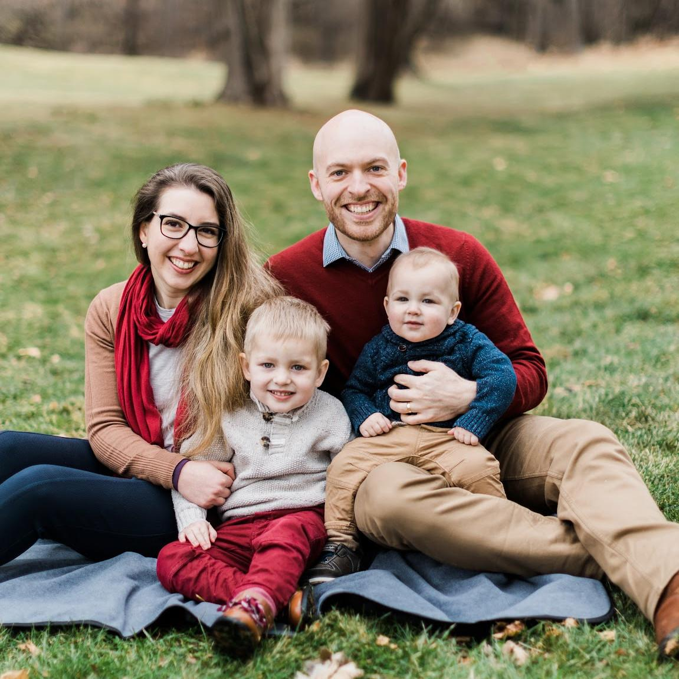

I had the great privilege of growing up in a Christian home where God and His Word were revered. At the age of seven, I came to understand I was a sinner and no amount of good things I did would undo my sin. I also learned that God, in His mercy and justice, had provided a solution. He punished His own Son, Jesus Christ, and would pardon me if I put my trust in Him. I did.   
  
As a young adult, I spent a couple years doing church planting and evangelistic work, before starting a career. I taught myself programing and software development and held several roles before joining the JAARS as a software engineer on the FlightSpan team.  
  
My wife, Emily, and I live near Oshkosh in the Fox Valley, and we first learned of JAARS’ need for a software engineer when we “accidentally” stumbled across the JAARS tent at AirVenture last year.  
  
Emily, is a missionary kid, and we both have a desire to see the church grow. We are active in discipleship and Bible teaching in our local church, and enjoy serving God’s people around the world with JAARS.