David Holsten
MAF, President

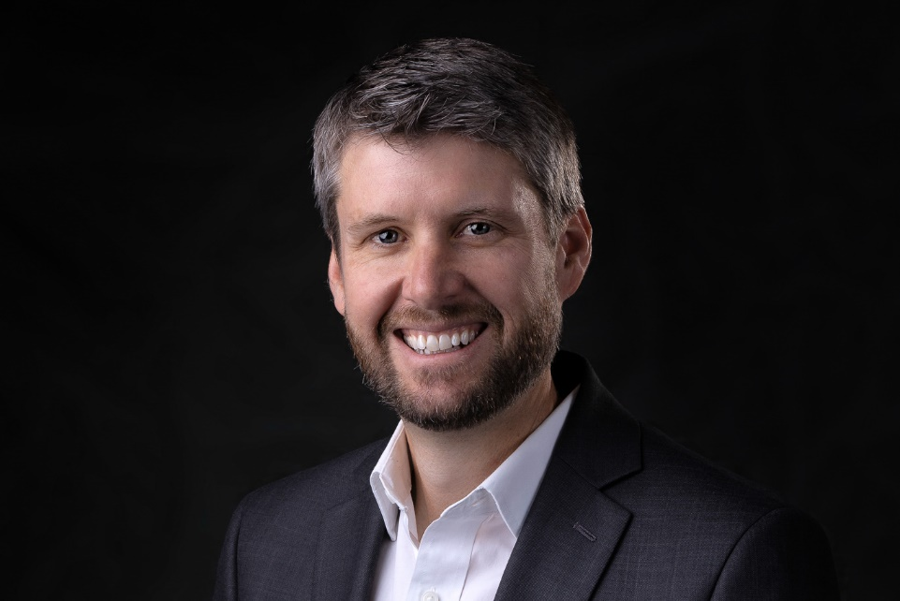

David Holsten assumed the presidency of MAF-US on July 16, 2018. He and his wife, Natalie, joined MAF in 2000.

During his years of service, initially as a missionary pilot/mechanic, David successfully carried out several leadership roles, including chief pilot, program manager, and regional director for Indonesia.

He became a Christian at an early age and was nurtured in his faith by his family, as well as by his church and youth group. David received a Bachelor of Science degree in Missionary Aviation Technology from Moody Aviation, and holds a commercial pilot’s license with multi-engine rating, as well an airframe and power plant mechanic’s license. Prior to joining MAF he worked as a flight instructor with Moody Aviation for two years.

In leading MAF, David relies on God’s guidance and actively seeks the counsel of the executive leadership team and the board of directors, as well as that of MAF staff. He says, “It is my desire to not only be a part of addressing the significant physical needs of isolated people, but to also help them grow in their walk with the Lord. I want the message of the gospel to be clearly displayed in all we do.”

David and Natalie reside in Nampa, Idaho, and have four children.

